Finding Narrow Passages with Probabilistic Roadmaps: The Small-Step Retraction Method

Mitul Saha⁽¹⁾ Jean-Claude Latombe⁽¹⁾ Yu-Chi Chang⁽²⁾ Friedrich Prinz⁽²⁾
(1) Computer Science Department
(2) Department of Mechanical Engineering
Stanford University, Stanford, CA 94305, USA

Abstract: Probabilistic Roadmaps (PRM) have been successfully used to plan complex robot motions in configuration spaces of small and large dimensionalities. However, their efficiency decreases dramatically in spaces with narrow passages. This paper presents a new method – small-step retraction – that helps PRM planners find paths through such passages. This method consists of slightly “fattening” robot’s free space, constructing a roadmap in fattened free space, and finally repairing portions of this roadmap by retracting them out of collision into actual free space. Fattened free space is not explicitly computed. Instead, the geometric models of workspace objects (robot links and/or obstacles) are “thinned” around their medial axis. A robot configuration lies in fattened free space if the thinned objects do not collide at this configuration. Two repair strategies are proposed. The “optimist” strategy waits until a complete path has been found in fattened free space before repairing it. Instead, the “pessimist” strategy repairs the roadmap as it is being built. The former is usually very fast, but may fail in some pathological cases. The latter is more reliable, but not as fast. A simple combination of the two strategies yields an integrated planner that is both fast and reliable. This planner was implemented as an extension of a pre-existing single-query PRM planner. Comparative tests show that it is significantly faster (sometimes by several orders of magnitude) than the pre-existing planner.

1. Introduction

Probabilistic Roadmaps (PRM) are a general and powerful approach to plan collision-free paths for robots and virtual characters in geometrically complex environments [ABD+98, AG99, AW96, BK00, KSLO96, HLM99, SAL02]. A PRM planner samples robot configurations at random with some probabilistic distribution and retains the collision-free ones as nodes – called milestones – of a graph (the roadmap). It connects each milestone to a small number of neighboring milestones by local paths (usually, straight-line segments in configuration space) and retains the collision-free connections as the roadmap edges. Sampled configurations and connections between milestones are tested using a collision checker to determine whether the robot overlaps (i.e., collides with) workspace obstacles. A fast BVH (Bounding Volume Hierarchy) checker is often used, as it can handle complex geometry [CLMP95, GLM96, LM04, Qui94]. In this way, the PRM planner avoids the prohibitive cost of computing a complete geometric representation of the collision-free subset – called free space – of the robot’s configuration space.

The robot’s start and goal configurations, s and g, are included among the milestones in the roadmap. The goal of the planner is to connect s and g by a sequence of edges in the roadmap. PRM planners differ among themselves by the sampling and connection strategies [SAL02] they use. In particular, multi-query planners pre-compute a roadmap and then use this roadmap to process multiple queries, each defined by a distinct pair (s,g) [KSLO96]. To process a query (s,g), they first connect s and g to the roadmap. To make this connection feasible, the roadmap must cover free space well. In contrast, single-query planners build a new roadmap from scratch for each new query (s,g). This roadmap needs only linking s to g; it usually consists of two trees rooted at these configurations [HLM99].

It has been formally proven that, under rather general assumptions, PRM planners converge quickly toward a solution path, whenever one exists [HLM99, KKL98, KLMR98]. In other words, the probability that a planner finds a path when one exists goes to 1 quickly as the number of milestones grows. In practice, PRM planners have solved complicated problems, involving one or several robots, with few or many degrees of freedom, in environments with geometry modeled by 100,000’s of polygons. They have also been applied to problems involving constraints other than mere collision avoidance, for example, kinodynamic [HKLR02, LK01], closed-loop kinematics [CSL01, HA01, LYK99], contact [JX01], visibility [DK00], and equilibrium [BLR03] constraints.

However, PRM planners still have drawbacks. When solution paths must go through “narrow passages” in free space, their convergence is much slower and occurs at a later stage of the sampling process [KKL98, KLMR98, HKL+98, WAS99]. The reason is that such passages occupy relatively small volumes, so that the probability of sampling milestones inside them and eventually connecting s to g grows slowly with the total number of milestones. Furthermore, PRM planners are unable to detect that no solution paths exist, when this is the case [KSLO96]. Therefore, if a planner has not found a path after some pre-specified amount of computation, it simply reports ‘failure’.

The narrow-passage issue has attracted much attention in recent years. Several roadmap construction methods have been proposed to deal with this issue (see Section 2). The most notable ones are the filtering and the retraction methods. Filtering methods include Gaussian sampling [BOvdS99] and the bridge test [HJRS03]. They over-sample configuration space, but then use heuristics to retain relatively few promising milestones. Retraction methods [AW96, HKL+98, LTA03, WAS99] use configurations sampled in collision space as helpers to generate promising milestones.

In this paper we present a new retraction method, which we call small-step retraction because it only tries to retract barely colliding configurations into free space. It consists of pre-computing “thinned” geometric models of the robot and/or the obstacles, constructing a roadmap using the thinned models, and finally repairing portions of this roadmap that are not in free space by retracting them out of collision. Thinning an object is done by reducing the volume it occupies around its medial axis, as described in Section 4 This operation guarantees that the free space associated with the thinned models – we call it fattened free space F* – is a superset of actual free space F. Narrow passages in F become wider in F*, making it easier to connect a roadmap through them (Section 3). But there is also a risk that some passages, called false passages, exist in F* that were not present in F. Paths through such passages cannot be repaired. For this reason, we propose two repair strategies (Section 5). The “optimist” strategy assumes that false passages are not an issue and that, consequently, repairs will always be possible. So, it postpones repairs until a complete path has been found in F*; then, it repairs only the portions of this path that are not in F. It is often very fast, but returns failure in cases (relatively rare in practice) where the generated path traverses a false passage. Instead, the “pessimist” strategy immediately repairs all parts of the roadmap that are not in F. It is slower, but more reliable. A simple combination of the two strategies yields an integrated planner that is both fast and reliable.

This small-step retraction method has several advantages over previous retraction methods:

- Most previous methods try to repair all colliding configurations, most of which are deeply buried into obstacle regions. This is computationally expensive. Only repairing those configurations where thinned objects do not overlap is much faster.

- The method in [HKL+98] also performs a form of small-step retraction. To test whether a colliding configuration should be repaired, it computes the penetration depth of the robot in obstacles. Such computation is notoriously expensive for non-convex objects [LM04].

- Our method works well even when there are no narrow passages in free space. In contrast, previous retraction methods incur a significant overhead in running time.

- While most previous narrow-passage methods were designed for multi-query roadmaps, ours works with single-query planners. In practice, such planners are often much faster per query than multi-query ones, hence more useful.

We have implemented the small-step retraction method as a new planner – called SSRP – which is an extension of SBL, a pre-existing single-query PRM planner described in [SAL02]. SBL (which stands for Single-query Bi-directional Lazy-collision-checking) builds a roadmap made two trees of milestones, each rooted at one of the two query configurations, until a collision-free local path connects a milestone in one tree and a milestone in the other tree. Its efficient lazy collision-checking strategy postpones collision tests along the edges of the roadmaps. A brief overview of SBL is given in Appendix for completeness of this paper. We tested SSRP on many examples, some presented in Section 6. On problems with narrow passages, it is consistently faster than SBL, usually by orders of magnitude. On problems without narrow passages, it is as fast as SBL.

2. Related Work

The following review focuses on previous work studying the impact of narrow passages on PRM planning and describing methods created to deal with them.

2.1. Narrow passages
Although the narrow-passage issue was recognized when PRM planning was first introduced, neither the notion of a narrow passage, nor its impact on PRM planning is straightforward.

In [KKL98], the clearance of a path is defined as the minimum distance between a configuration on this path and free space boundary. It is used to establish an upper bound on planning time. However, path clearance incompletely characterizes narrow passages. Indeed, it is independent of the length of a passage and the number of dimensions along which it is narrow. It does not capture either the fact that the passage might be jaggy, which may greatly affect the difficulty of finding a path through it. Furthermore, while finding a path through a single isolated passage may be difficult, many parallel narrower passages may turn out easier to deal with.

A more careful analysis of narrow passages yields the notion of the expansiveness of free space F [HLM99]. Given any S ⊂ F, the lookout of S is the set of all configurations in S that can be connected by a local path to a configuration in F\S. F is expansive is all its subsets have a relatively large lookout. Expansiveness was used to provide tighter bounds on the running time of a PRM planner. In [HKL+98] it is argued that a slight fattening of free space dramatically increases its expansiveness, hence the easiness of PRM planning. This argument is consistent with the observation reported in Section 3.1.

2.2. Sampling and connection strategies
A sampling strategy is defined by the probabilistic distribution used to sample milestones. The simplest one is the uniform distribution. More complex strategies vary the probabilistic distribution during roadmap construction. A connection strategy chooses which pairs of milestones to connect.

Many strategies have been proposed for PRM planners. A survey can be found in [SAL02]. Their goal is to process path-planning queries at minimal computational cost. For multi-query planners, this means building a roadmap with two properties [HKL+98]:

- Coverage: the roadmap must be distributed over free space, so that it is easy to later connect any query configuration to it.

- Connectedness: there must be a one-to-one correspondence between the path-connected components of the free space and those of the roadmap.

In single-query planners, strategies aim at constructing the smallest possible roadmap connecting a given pair of query configurations.

All successful strategies alleviate the narrow passage problem to some extent. For instance, the sampling strategy described in [KSLO96] pre-computes a roadmap in two stages: a first roadmap is computed by sampling configurations at random, with a uniform distribution over configuration space; next, additional configurations are sampled uniformly in neighborhoods of milestones that have no or few connections to other milestones. The rationale is that poorly connected milestones lie in “difficult” regions of free space, such as narrow passages. Another general sampling strategy that has given good results on problems with narrow passages is PRT (Probabilistic Roadmap of Trees), which constructs a roadmap as collections of trees [ABC+03]. Connection strategies are also relevant to finding paths through narrow passages. For instance, in [Isto02] the use of search techniques to generate local paths yields multi-query roadmaps with fewer connected components and

However, the above strategies do not attack the narrow-passage issue by specifically trying to sample milestones within narrow passages. It is usually considered that a strategy dedicated to finding narrow passages should exploit configurations sampled in collision space to increase the planner’s chances of eventually placing milestones in these passages. Two such families of sampling strategies are the filtering and the retraction strategies.

2.3. Filtering strategies
Filtering strategies consist of over-sampling configuration space and retaining each sampled collision-free configuration as a milestone with a probability estimating its likelihood of being in a narrow passage. As many configurations sampled in free space do not end up being retained as milestones, more time is spent on average per milestone. But the resulting set of milestones is better distributed and smaller, so that fewer connections are eventually attempted between them. Since testing that a connection is collision-free takes much more time than testing a single configuration (in practice, 10 to 100 more time), one may save a significant amount of time in total. Gaussian sampling [BOvdS99] and the bridge test [HJRS03] are two particular filtering strategies.

Gaussian sampling generates each milestone as follows. It samples a configuration c uniformly at random from the configuration space and then a second configuration c’ using a Gaussian distribution centered at c. If only one of the two configurations is collision-free, it retains it as a milestone with probability 1. Instead, if both c and c’ are collision-free, it retains either one as a milestone, but with low probability. The resulting distribution of milestones is sparse in wide-open region of free space and denser near free space boundary. Since configurations in narrow passages are necessarily near this boundary, Gaussian sampling increases the likelihood of generating milestones in narrow passages. However, especially in high-dimensional spaces, most milestones are still “wasted” in regions close to free space boundary, but not in narrow passages.

For this reason, the bridge test extends the idea underlying Gaussian sampling. It samples two configurations c and c’ in the same way as Gaussian sampling. If both are in collision and the mid-configuration (c+c’)/2 is collision-free, then it retains the mid-configuration as a milestone with probability 1, since it very likely lies in a narrow passage. Otherwise, if only one of the two configurations c and c’ is collision-free, it retains it as a milestone with lower probability. If both c and c’ are collision-free, it retains either one as a milestone with very low probability. At first glance, the bridge test looks like an expensive method, but results show that it is a very promising approach.

Both Gaussian sampling and the bridge test have been designed and implemented for multi-query planners. This makes sense since these planners spend a much greater fraction of their time testing connections between milestones than single-query planners, especially a planner like SBL which postpones collision tests along edges. It is not obvious whether these strategies could be adapted to speed-up single-query planners as well.

2.4. Retraction strategies
Retraction strategies exploit configurations sampled in collision space to guide the search for promising milestones. They consist of moving colliding configurations out of collision.

One technique casts rays along directions selected at random from a colliding configuration c and performs discrete walks along these rays until a configuration tests collision-free [AW96]. Fixed-step and bisection (binary search) walks have been used. But in high-dimensional spaces, rays may easily miss narrow passages, especially if c is deeply buried in collision space.

Other techniques use the medial axis (MA) of the workspace [GHK99, HCK+00, HK00], which is defined as the subset of points for which at least two points in the obstacle boundary are equally close. In [HK00] each configuration c sampled by the planner is adjusted by minimizing distances between points (called “handles”) pre-selected by the user on the robot and the MA.

A different type of MA technique is introduced in [WAS99] for a rigid free-flying robot. Here, the PRM planner retracts each configuration it samples at random onto the free space’s MA. To avoid the prohibitive cost of pre-computing this MA, an iterative technique translates the robot until its configuration lies in the MA. However, sections of narrow passages cannot be sampled this way because they would require rotating the robot as well. An extension of this technique to arbitrary robots is discussed in [LTA03].

In general, the above retraction techniques are expensive because they retract all configurations sampled by the planner, including those which lie deep in collision space. Observation #1 reported in Section 3.1 suggests that it is sufficient to retract configurations near the boundary of free space, which is what our small-step retraction approach does. This same idea has been previously exploited in [HKL+98], but using the penetration depth of the robot into workspace obstacles to decide whether a configuration is worth retracting. The high cost of computing penetration depth of non-convex objects was a serious limitation of this technique, which has never been tested in geometrically complex environments. Instead, in our approach, we pre-compute a thinned version of the robot and obstacle geometry. We retract a configuration c only if the thinned robot placed at c does not collide with thinned obstacles.

The idea of shrinking robot geometry was introduced in [Bag97], where a colliding straight path in configuration space is progressively transformed into a collision-free path by growing back the robot links to their original geometry. However, this iterative transform may get stuck into a dead-end and the planner has no systematic way of dealing with such failures. In addition, the shrinking technique in [Bag97] only applies to simple robot links modeled as rectangular boxes.

3. Motivation from Experimental Observations

Several components of our small-step retraction method were suggested by observations made during simple preliminary experiments in two-dimensional configuration spaces. We report on two key observations below. These observations have been later confirmed by our experiments with the SSRP planner (Section 6).
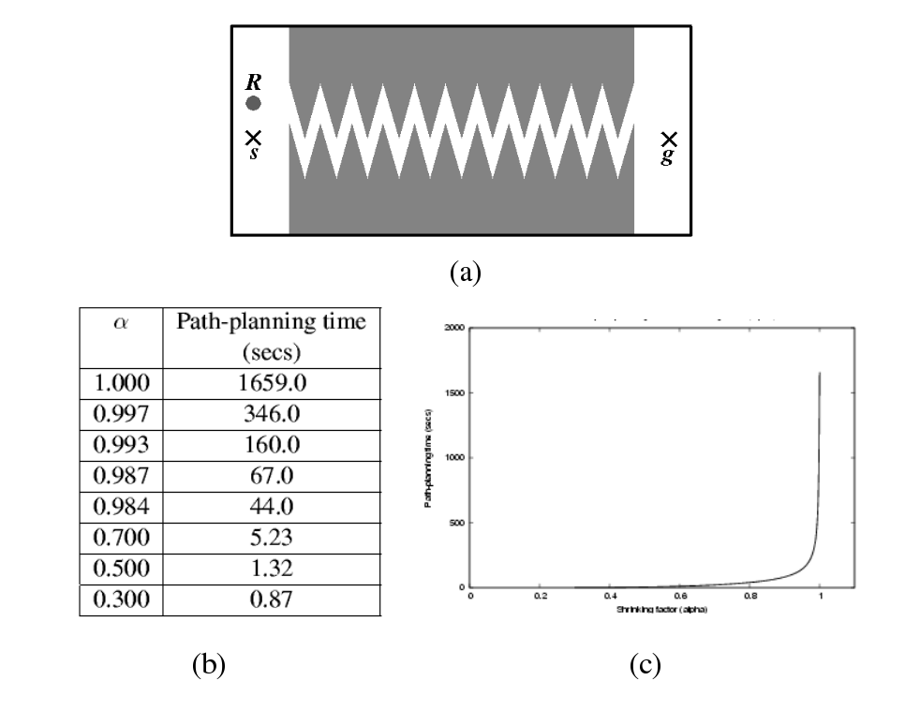
Figure 1: Planning a path through a narrow passage of varying width (Observation #1)

3.1. Observation #1
Consider the example in Figure 1(a). The robot R is a small disc of radius r. Its configuration is defined by the coordinates of its center. The start and goal configurations are s and g, respectively. The two obstacles create a long and narrow jaggy passage of width w, which the robot must traverse to reach g from s. Although the figure shows the robot’s workspace, the configuration space is also two-dimensional with similar geometry. However, the passage’s width in configuration space is w-2r, since the obstacles must be grown by the robot’s radius r.

We used the PRM planner SBL [SAL02] on this example, with decreasing values of r. Smaller values of r yield wider passages in configuration space. For each value of r, SBL was run 100 times with different seeds of the random number generator, each time until a path was found. We measured the average planning time over the 100 runs. For all values of r, in all runs, s and g were fixed as shown in Figure 1(a).

The table in Figure 1(b) lists the average planning times, for decreasing values of the ratio α = 2r/((1-ε)w), where ε was set to 0.005. The value α = 1 corresponds to the largest radius (1-ε)w/2, hence the narrowest passage in configuration space (with a width of 0.005×w). The value α = 0.3 corresponds to the widest passage with a width of roughly 0.7×w. The plot of these times in Figure 1(c) clearly shows that planning time decreases dramatically when α gets only slightly smaller than 1. The curve flattens out quickly (around α = 0.95), but planning time is already a small fraction of what it was for α = 1. Planning time for α = 0.987 is almost 38 times smaller than for α = 1.

These results are easy to explain: widening the narrow passage yields a large relative increase of its volume, so that the probability that each configuration sampled at random falls into the widened passages also increases. This simple observation is at the core of the small-step retraction strategy. Fattening free space by only a small amount – which is achieved by thinning the robot and/or the obstacles – greatly simplifies the task of a PRM planner. Of course, a path in fattened free space may not fully lie in actual free space. The purpose of small-step retraction is to “repair” the portions that are not in free space.

3.2. Observation #2
Consider now the environment of Figure 2(a) in which there are two narrow passages: one at the top of the workspace has width w₁ and one at the bottom has width w₂. The robot R is a disc of radius r.

In this example, we ran two series of tests. In the first, we set w₁ = w₂ and we considered three pairs (s_{i},g_{i}), i = 1 to 3, of query configurations, as shown in the figure. For each pair, the configurations lie on both sides of the passages, with (s₁,g₁) closest to the top passage and (s₃,g₃) at mid distance between the two passages. For each pair (s_{i},g_{i}), we ran SBL 100 times and we counted the numbers of paths through each passage. The results in Figure 2(b) indicate that with high frequency SBL generates paths through the closest narrow passage. For instance, for (s₁,g₁), 88% of the paths traverse the top passage. As one would expect, for (s₃,g₃), the paths are equally divided between the two passages.

In the second series of tests, we used only the pair (s₃,g₃) and we set w₂ = β×w₁, with β ≥ 1. We ran SBL for increasing values of β (100 times for each value) and we counted the number of paths through each passage. The results are given in Figure 2(c). With high frequency SBL generates paths through the wider passage. The fraction of paths through this passage increases quickly when β increases slightly and reaches 100% for β = 1.5.

This experiment shows that, in the presence of multiple narrow passages, SBL tends to generate paths through the “easiest” one. We used this observation to design the overall strategy of SSRP. As mentioned above, fattened free space may contain false narrow passages (that do not exist in actual free space), but often these false passages are “more difficult” than the widened true passages. Hence, it is reasonable to assume that in most cases a path in fattened free space will be repairable into a path in actual free space. The optimist strategy of SSRP makes this assumption, but the pessimist strategy does not. Since the former is usually orders of magnitude faster than the latter, SSRP tries it first, and uses the pessimist strategy only as back-up.

X s₁
X s₂
X s₃
X g₁
X g₂
X g₃
w₁
w₂
R

(a)

β | % Τοp | % Bottom
1.000 | 52 | 48
1.003 | 9 | 91
1.006 | 5 | 95
1.012 | 2 | 98
1.500 | 0 | 100

(start,goal) | % Top | % Bottom
(s₁,g₁) | 88 | 12
(s₂,g₂) | 80 | 20
(s₃,g₃) | 52 | 48

(b) (c)

Figure 2: Choosing between two narrow passages (Observation #2)

4. Object Thinning

The purpose of object thinning is to construct a version of the robot and obstacle geometry that the PRM planner’s collision checker can use to test whether a configuration is barely colliding – in which case it is worth trying to retract it into free space – or not. The thinning method presented below applies to both robots and obstacles, but our experiments with SSRP show that thinning robots (and not obstacles) is often sufficient to achieve major planning speed-up. This is useful, since obstacles usually have more complex geometry than robots and change more often between tasks. So, their thinning is more computationally demanding.

The only constraint on thinning is that the space occupied by a thinned object be contained in the space occupied by the original object. So, in particular, if R(c) and R*(c) respectively stand for the space occupied by the original robot and the thinned robot at configuration c, then we must have R*(c) ⊂ R(c). Most scaling methods do not guarantee such result for non-convex objects. For a given object (robot link, obstacle), our method thins its geometry around the object’s medial axis MA. To thin a robot, we thin each of its links, while leaving the robot’s kinematics (relative positions of joints) unchanged.

4.1. Medial-axis computation
The MA of a 3D object X is the 2D locus of all centers of locally maximal balls contained in X [Blum67]. The points on the MA together with the radii of the associated locally maximal balls define the Medial-Axis Transform (MAT) of X. The locally maximal balls are called the MA balls. The entire geometry of X can be reconstructed from the MAT. A number of algorithms have been proposed to compute the exact or approximate MAT of an object (e.g., [ACK01, DZ02, HCK+99, HCK+00, Hoff94, FLM03]). Here, we use a new algorithm described in [CPRP04]. Since the thinning method presented in Section 4.2 depends partially on this algorithm, we describe it briefly below.

We assume that each object is modeled as a polyhedron. The MA of an object X is constructed by stitching together several sub-MA’s, each contributed by a governing boundary element (face, edge, or vertex) of X. Each sub-MA is computed independently from the others using graphics hardware. Since our thinning method only uses the subset of the MA contributed by faces, we describe the construction and assembly of the sub-MA’s governed by faces of X.

By definition, each point p on a sub-MA corresponds to the closest point q on the governing element e, where the MA ball centered at p touches e. The open line segment pq does not intersect the MA or the object boundary. In addition, every point on the MA belongs to at least two sub-MA’s and is therefore equidistant from their governing elements.
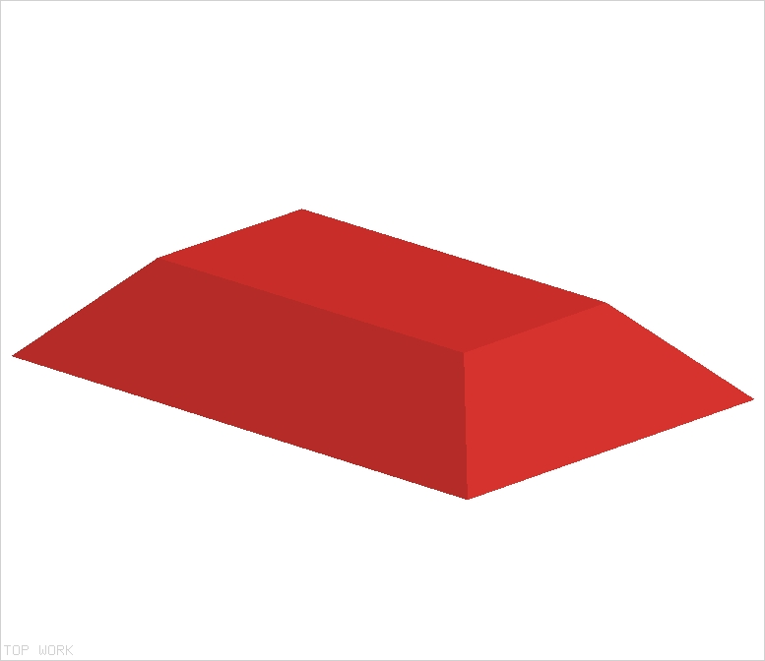
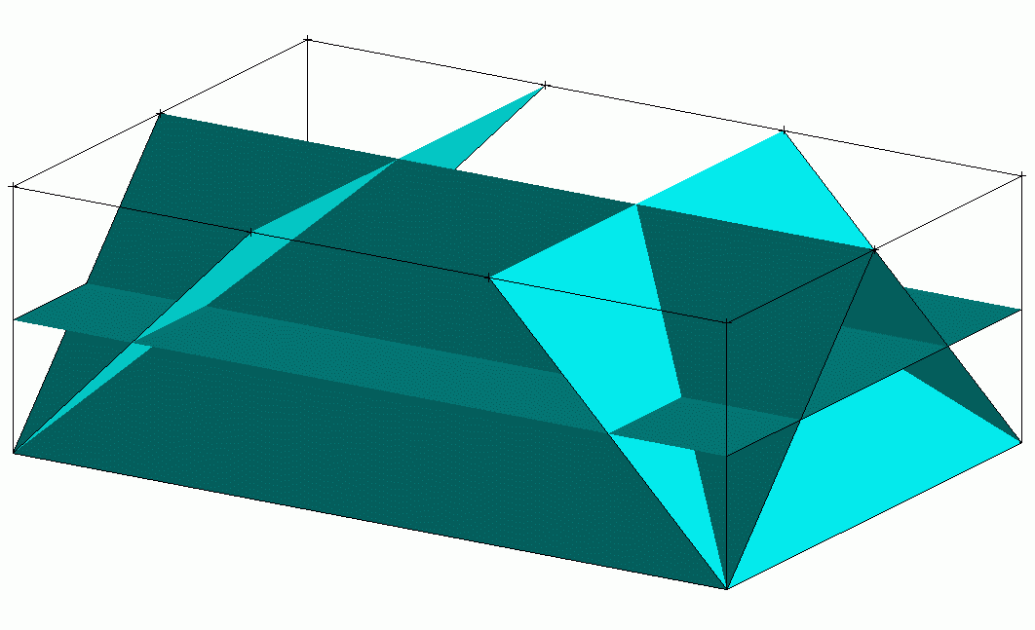


(b)
(c)
(a)

Figure 3. Construction of a sub-MA for a box-shaped object: (a) bisecting planes associated with bottom face; (b) visible portions of planes along normal direction rendered with different colors; (c) sub-MA.

The construction of the sub-MA governed by face e of X is illustrated in Figure 3. We first consider every other face e’ of X that fully or partially lies on the inward side of the supporting plane of e. Each e’ yields the bisecting plane of all points equidistant from e and e’. See Figure 3(a), where e is the bottom face. In this example, each of the other 5 faces of the block contributes a bisecting plane. The bisecting planes are then viewed along the normal direction of e. The visible portions (i.e., the portions not occluded by other bisecting planes) form the sub-MAT governed by e. They are obtained by rendering the bisecting planes with distinct colors in a graphic buffer, as illustrated in Figure 3(b). The content of the buffer is then converted into the sub-MAT, as depicted in Figure 3(c). A different technique using graphic hardware was previously presented in [HCK+99].

Once the sub-MA’s governed by all faces of X have been computed, they are stitched together to form the MA. Consider two sub-MA’s having e and e’ for their respective governing elements, such that each sub-MA contains a face contributed by the bisector plane of e and e’. The two sub-MA’s can be stitched together by aligning them relative to this plane. The entire MA is obtained by repeating this operation for all sub-MA’s.

Note that to construct a complete MA, one would also have to consider concave edges and vertices as governing elements [CPRP04]. Such elements may contribute curved portions of the MA, but as indicated before, these portions of the MA are not used by our thinning method.

4.2. Thinning method
To thin object X, we reduce the radii of the MA balls and we construct the geometry defined by the reduced balls. Different ways of reducing radii produce distinct outcomes. For example, we may multiply the radii of the MA balls by a constant factor β < 1, or instead subtract a constant offset δ from all radii and remove all MA balls whose radii are less than δ (see Figure 4). In our implementation, we chose the latter technique mainly because the outcome is much easier to compute. We set δ to α×r_{max}, where r_{max} is the radius of the largest MA ball and α is a constant less than 1 called the thinning factor; in our experiments, we used α ≈ 0.2.

For each sub-MA governed by face e, let P denote the plane obtained by translating the supporting plane of e inward by the offset distance δ. We project the portions of the sub-MA faces that lie on the inward side of P into P. The boundary of the thinned geometry of X consists of all the projected sub-MAT faces for all governing faces of X. This technique is illustrated in 2D in Figure 5, where X is a rectangle (in dashed line) and e is its bottom edge; the sub-MAT governed by e consists of three edges, which are partially or fully projected into the line P. The offset distance δ can be set to different values for different objects.

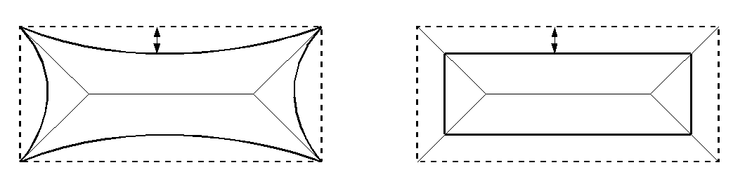
r×β
δ
(a) (b)

Figure 4: Different thinning methods: (a) the radii of MA balls are multiplied by a constant factor β smaller than 1; (b) they are reduced by a constant amount δ.
e
δ
P
Figure 5: Thinning of sub-MA

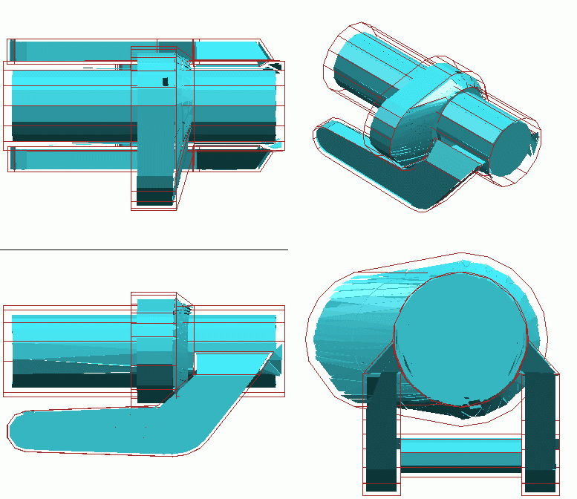

Figure 6: Thinned robot component

This “projection” technique often leads to transforming a single face e of X into several co-planar faces of the thinned objects. So, most objects thinned by this technique have a greater number of polygonal faces than the original objects. However, this has no discernable impact on the running time of our planner’s collision checker, which uses a bounding-volume hierarchy approach. An alternative thinning technique would be to compute the intersection of plane P with the volume bounded by e and the sub-MAT it governs. We chose the “projection” technique for its robustness, as it is insensitive to floating-point approximations.

The incompleteness of the MA may cause the boundary of the thinned object to contain gaps. There are simple ways to fill these gaps, and we have actually implemented one of them. But, in practice, gaps are small enough to be ignored. At worst, they cause the collision checker to incorrectly classify a few configurations sampled by the PRM planner as lying in fattened free space. The impact on the overall performance of the planner is negligible.

Figure 6 shows the result of thinning a component of an ABB IRB 2400 robot. The outer wire frame represents the original component and the inner shaded model depicts its thinned geometry. Similarly, Figure 7(a) displays the entire robot (wire frame) and its thinned geometry (shaded model). We decomposed this 6-degree-of-freedom robot into 10 components. The table in Figure 7(b) lists the numbers of polygons modeling each component (original and thinned geometry) and the running times (in seconds) to compute its MA and thin its geometry. Note that the computation the sub-MA’s could easily be parallelized.

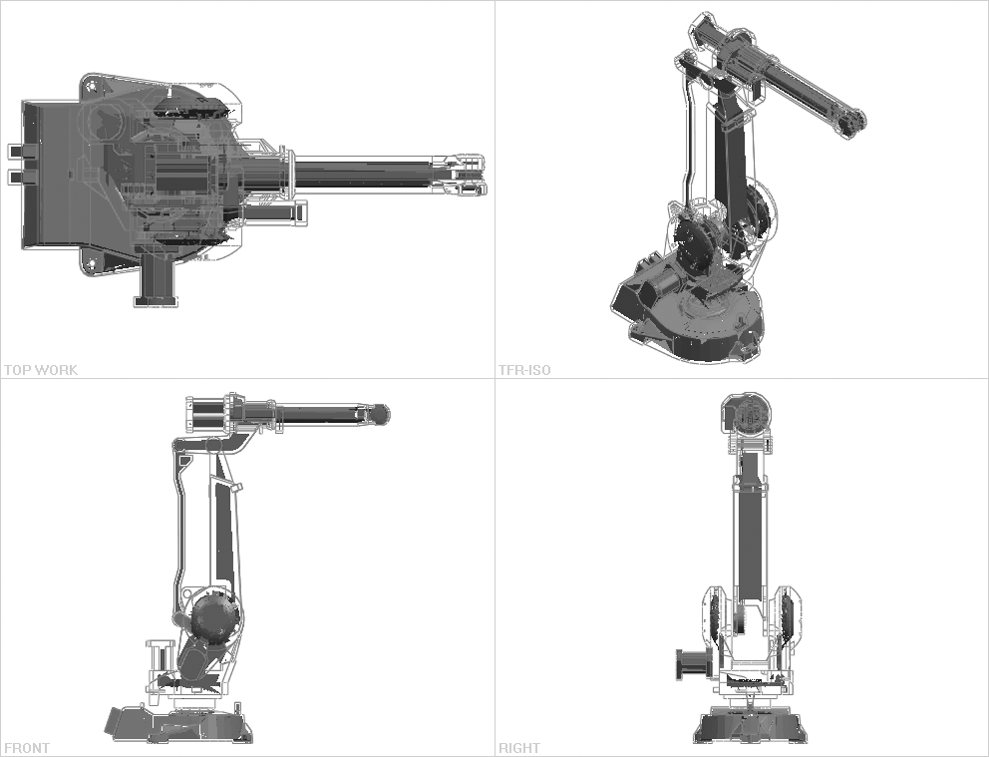
(a)

components | #polygons (original model) | #polygons  (thinned model) | MA computation time (sec.) | thinning time (sec)
1 | 321 | 1531 | 313 | 0.5
2 | 1455 | 10293 | 1916 | 2.5
3 | 205 | 517 | 206 | 0.5
4 | 137 | 847 | 129 | 0.5
5 | 135 | 1086 | 128 | 0.5
6 | 447 | 2239 | 461 | 0.9
7 | 698 | 2516 | 797 | 1.0
8 | 119 | 980 | 118 | 0.5
9 | 376 | 2713 | 452 | 0.9
10 | 160 | 863 | 151 | 0.5

(b)

Figure 7: Thinning the ABB IRB 2400 robot

4.3. Object thinning as a pre-computation step
In this paper, we consider object thinning as a pre-computation step for our planner. This means that we do not include its running time into the planner’s total running time. Since the algorithms for computing an object’s MA often take more time than the planner itself, this point deserves some discussion.

The main justification for seeing thinning as a pre-computation is that it needs to be done only once for each object, independent of this object’s position and orientation. So, it is not repeated for each new planning problem. Moreover, object models are often available long before they are used for motion planning, leaving plenty of time for the pre-computation. Finally, the generation of an object’s geometric model, e.g., by using a CAD modeler or by sensing real objects, often takes more time than computing its MA.

For similar reasons, several other computations are classically regarded as pre-computations in motion planning. For instance, like ours, most planners assume that geometric models describe object surfaces by polygonal meshes. When models are not input in this form, extracting polygonal meshes from the given representation is treated as a pre-computation step. Similarly, if a planner uses a BVH collision checker (most PRM planners do), computing bounding-volume hierarchies is considered a pre-computation step, since it is done only once for each object.

Nevertheless, increasing pre-computation has drawbacks. In some robotics applications, object models are not available in advance and the sequence sensing-modeling-planning-execution must be executed as quickly as possible. Any additional computation reduces the robot’s reactivity. When time is less critical, one must still store pre-computed results and update them if geometric models are later modified. Fortunately, in most examples, we have observed that, for our planner, it is sufficient to thin the robot and leave the obstacles unchanged.

5. Small-Step Retraction Planner

Our small-step retraction planner SSRP is built upon the pre-existing SBL planner [SAL02], but we could have used almost any other single-query PRM planners as well. It combines two algorithms (each calling SBL) – Optimist and Pessimist. Optimist, which is very fast, but not fully reliable, is called first. If it fails to find a path, then SSRP calls Pessimist, a slower but more reliable algorithm.

Throughout this section, F denotes robot’s free space and F* fattened free space. F (resp. F*) is the set of all configurations where the robot (resp., the thinned robot) does not collide with workspace obstacles (resp., thinned obstacles). To test if a sampled configuration or a local path is in F (resp., F*), the planner uses a BVH (Bounding Volume Hierarchy) collision checker [GLM96, LM04, Qui94] that determines whether the boundaries of the robot and the obstacles (resp., the thinned robot and the thinned obstacles) intersect. By construction of the thinned objects, we have F ⊂ F*. We call the set ∂*F = F*\F the fattened boundary of F.

5.1. Optimist algorithm
Finding a path in F* is easier for a PRM planner than finding one in F because narrow passages have been widened. In addition, as true passages in F* are the results of widening passages existing in F, they are usually wider than false passages (if any), which did not exist in F. So, as suggested by Observation #2 (Section 3.2), a planner like SBL will more frequently generate paths through true passages than false ones.

Optimist constructs a roadmap in F* using SBL. It assumes that paths generated by SBL traverse true passages, hence can be easily repaired. So, it postpones repairs as much as possible. Only after having found a complete path in F* between the query configurations s and g does it try to repair this path by retracting the colliding portions into F. If it does not quickly repair the path, it simply returns failure. The algorithm is given below, with M referring to the geometric models of the robot and the obstacles and M* to the thinned models:

Algorithm Optimist(s, g, M, M*)
1. τ* ← SBL(s, g, M*)
2. Return Repair(τ*, M)

At Step 1, SBL searches for a path τ* in F*. Step 2 calls Repair to move the portions of τ* that are in ∂*F into F. The Repair algorithm returns either a path entirely in F, or failure. It first retracts the milestones on τ* out of collision, then its edges (straight segments). The following algorithm, Repair-Conf, is used to repair every milestone c on τ* that lies in ∂*F by sampling configurations inside balls B(c,ρ) of increasing radii ρ centered at c, starting with some small given radius ρ_{min} (the factor η > 1 used to increase ρ is an input constant):

Algorithm Repair-Conf(c, M)
1. ρ ← ρ_{min}
2. For k = 1, …, K do
2.1. Sample a configuration c’ uniformly at random from B(c, ρ)
2.2. If c’ ∈ F then return c’ else ρ ←ρ×η
3. Return failure

If Repair-Conf fails after K iterations, the milestone c and, so, the path τ* are considered non-repairable. Otherwise, the milestone c on τ* is replaced by the returned configuration c’. Once all milestones on τ* have been repaired, every path edge e that intersects ∂*F is repaired in turn. This is done recursively by calling Repair-Conf(c,M) with c set to the mid-point of e. Again, any failure causes Optimist to fail. Because repairable paths in F* usually lie close to the boundary of F, the parameter K is set relatively small, which avoids wasting time on non-repairable paths. In our implementation, we use K = 100.

5.2. Pessimist algorithm
However, SBL(s,g,M*) sometimes constructs paths through false passages. To illustrate, Figure 8 shows a hand-made pathological example in a 2D configuration space. The white region in this figure is free space F, the light and dark gray region the collision space, and the light grey region the fattened boundary ∂*F. The query configurations s and g are close to each other, but separated by collision space, so that a path in F must make a long detour through the passage at the top of the configuration space. In this example, F* contains a false passage (bottom) through which paths between s and g are much shorter. Such paths are more likely to be generated by SBL(s,g,M*) than paths through the wider, but further away top passage.

Unlike Optimist, Pessimist immediately repairs every configuration sampled in ∂*F, instead of waiting until a path in F* has been found. This is done by modifying SBL slightly. Within Pessimist, each time SBL samples a new configuration c, it proceeds as follows:

1. If c ∈ F, then add c to the set of milestones
2. Else if c ∈ ∂*F and Repair-Conf(c, M) returns a configuration c’
then add c’ to the set of milestones
3. Else discard c
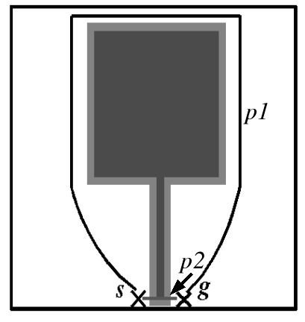
Figure 8: A “pathological” example where Optimist is likely to fail

SBL uses a lazy collision-checking strategy that postpones testing edges between milestones until it has found a path of milestones between the two query configurations (See Appendix). Only then, it checks that the edges contained in the path are collision-free. If an edge is found to collide, it is removed from the roadmap. SBL does not give up, but continues sampling new milestones until it finds another path. We chose to keep this feature of SBL un-changed in Pessimist. So, Pessimist does not repair colliding edges, nor paths through false passages.

For every configuration c sampled outside F, Pessimist calls the collision checker twice and repairs c if it lies in ∂*F, even though many repaired configurations will not end up being on the final path. Hence, on average, it spends more time per milestone than either Optimist or plain SBL. But, by repairing milestones immediately, it avoids the fatal mistakes of Optimist. Because its sampling strategy yields better distributions of milestones, it usually needs smaller roadmaps to generate paths that the plain SBL planner.

5.3. Overall Planner
As the experiments reported in Section 6 will show, when Optimist succeeds, it is much faster than Pessimist (often by very large factors). But Pessimist is more reliable and in general still significantly faster than SBL. These results led us to design our small-step retraction planner, SSRP, by combining Optimist and Pessimist as follows:

Algorithm SSRP(s, g, M, M*)
1. Repeat N times
If Optimist(s, g, M, M*) returns a path, then return this path
2. Return Pessimist(s, g, M, M*)

Our experiments show that if Optimist fails a few times in a row, then it continues failing consistently. So, we set N small (more precisely, equal to 5 in our implementation). Since Optimist is much faster than Pessimist, the impact of successive failures of Optimist on the total running time of SSRP is small.

6. Experimental Results

Optimist and Pessimist are written in C++ using the PRM planner SBL from the Motion Planning Kit (MPK) available at http://robotics.stanford.edu/~mitul/mpk. All experiments reported below were performed on a 1GHz Pentium III PC with 1GB RAM.

6.1. Test environments
Figure 9 shows several environments with difficult narrow passages used to evaluate our algorithms and overall strategy:

- In (a) and (b) an IRB 2400 robot must move among thin obstacles. In (b), the robot is in a bar cage and must find a way for its endpoint in and out of the cage, between bars.

- In (c) the robot must move from an initial configuration where the end-effector (a welding gun) is outside the car to a goal configuration where it is deep inside the car. The only way in is through the door window.

- In (d), the robot’s end-effector forms a close loop that must be taken off one of the tall vertical poles and placed around the other. The robot must first move up the end-effector along the first pole and then down along the second pole. In this case, free space contains two narrow passages separated by a large open area where the end-effector does not encircle any of the two poles.

- (e) is inspired by typical spot welding tasks. The welding gun must be inserted on both sides of a flat object.

- (f) is a toy example designed to create a short false passage in fattened free space.

- Finally, the so-called alpha puzzle in (g) is a classical test for PRM planners [ABD+98]. One of the two identical objects is arbitrarily chosen to be a 6-degree-of-freedom free-flying robot and the other to be a fixed obstacle. The geometry of the objects and the small clearance between them create a very narrow passage in free space that can only be traversed by a tight coordination of rotation and translation of the robot. The alpha puzzle example exists in several versions named 1.0 to 1.5. Alpha puzzle 1.0 has the narrowest passage and hence is the hardest to solve. In our tests, we used the versions 1.0 and 1.1.

In examples (a), (b), (c), (f) and (g), we only thinned the robot. Instead, in examples (d) and (e), we only thinned the obstacles, because they have much simpler geometry. (Experiments not reported here show that in all these examples thinning both the robot and the obstacles results in no significant additional reduction of planning time.) All objects were thinned with the MA-based method described in Section 3 using the thinning factor α ≈ 0.2. Thinning is considered a pre-computation step, whose running time is not included in the planning times below (see Section 4.3).

Figure 10 shows two additional test environments (h) and (i) for which there are no narrow passages in free space. They were also used to evaluate our planner, since many practical planning problems do not involve difficult narrow passages.

The table of Figure 11 gives the number of polygons modeling the objects in all test environments, except (f).
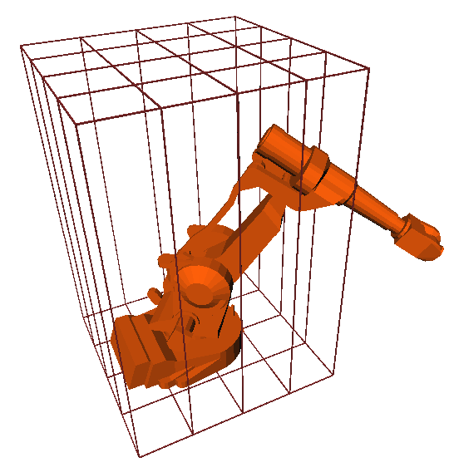
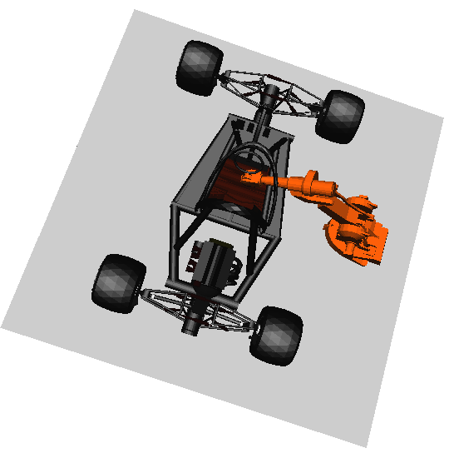

(a)
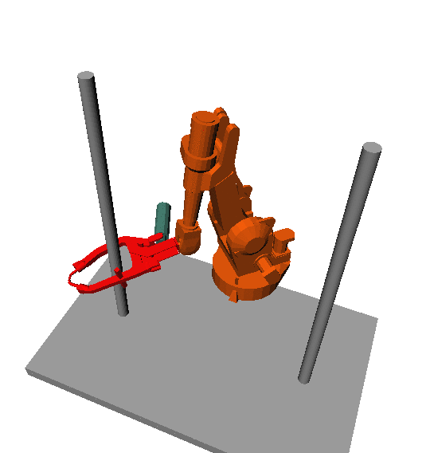
(b)

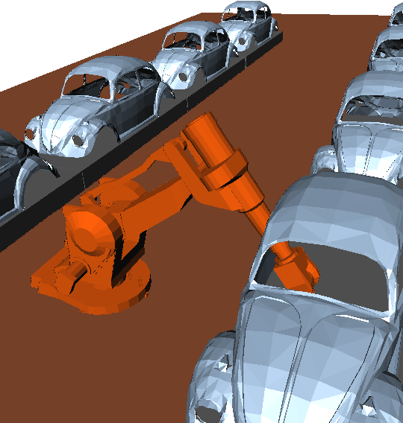

(c)
(d)

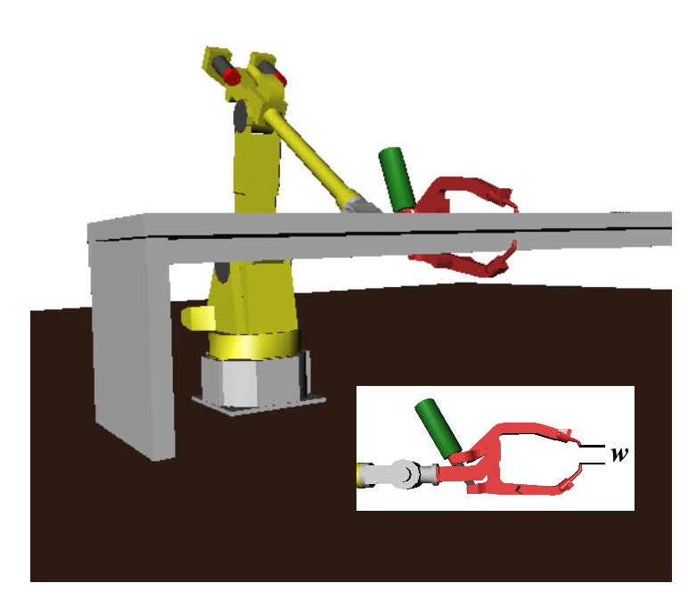



(e)
(f)

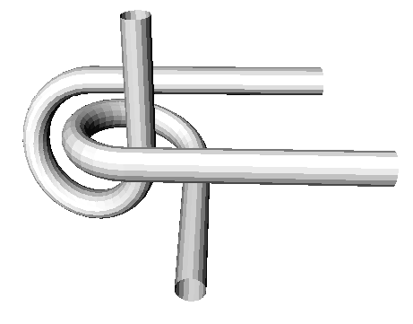

(g)

Figure 9: Test environments with narrow passages
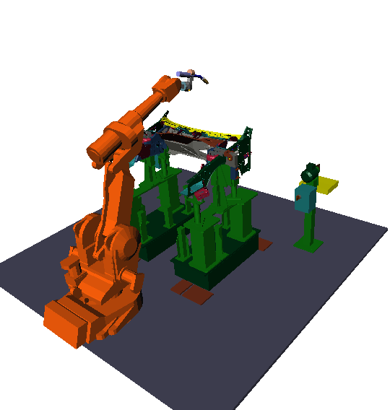
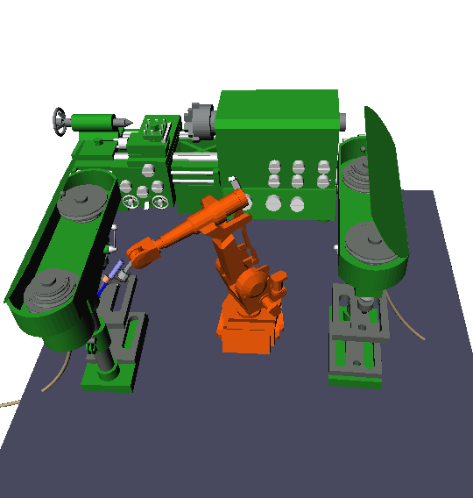

(h)
(i)

Figure 10: Test environments without narrow passages

 | (a) | (b) | (c) | (d) | (e) | (g) | (h) | (i)
robot | 4053 | 4053 | 4053 | 7596 | 4505 | 1008 | 4853 | 4853
thinned robot | 23585 | 23585 | 23585 | 7596 | 4505 | 8976 | 24385 | 24385
obstacles | 43530 | 432 | 4028 | 140 | 48 | 1008 | 74681 | 83934
thinned obstacles | 43530 | 432 | 4028 | 286 | 80 | 1008 | 74681 | 83934

Figure 11: Number of polygons in models

 | % success Optimist | T_{Optimist} | T_{Pessimist} | T_{SSRP} | T_{SBL}
(a) | 100 | 9.4 | 1284 | 9.4 | 12295
(b) | 100 | 32 | 1040 | 32 | 5955
(c) | 100 | 2.1 | 15 | 2.1 | 41
(d) | 100 | 492 | 634 | 492 | 863
(e) | 100 | 65 | 351 | 65 | 631
(f) | 0 | 12 | 325 | 386 | 572
(g)-1.1  (g)-1.0 | 0  100 | 111  13588 | 2810  >100000 | 3365  14069 | >100000  >100000

Figure 12: Performance of Optimist, Pessimist, SSRP, and plain SBL in the environments of Figure 9

6.2. Results
The table in Figure 12 lists the running times of Optimist, Pessimist, SSRP, and plain SBL on planning problems in the environments of Figure 9. Each time is expressed in seconds and is an average over 100 runs on the same pair of query configurations, except for SBL in example (g) and Pessimist in example (g)-1.0, which found no path in several runs, some taking more than 30 hours of computation (which we indicate with “>100000”). The first column of the table identifies the environment. The second column gives the success rate of Optimist. On problems (a)-(e) Optimist consistently succeeded to find a path, while on the last two it consistently failed. The columns T_{Optimist} and T_{Pessimist} give the average running times of Optimist and Pessimist, respectively (for better comparison, we ran Pessimist even when Optimist succeeded). Except for (g)-1.0, Pessimist never failed. The column T_{SSRP} indicates the total planning time of SSRP. It is equal to T_{Optimist} in examples (a)-(e) and (g)-1.0 and to 5×T_{Optimist}+T_{Pessimist} in examples (f) and (g)-1.1, since Optimist is run 5 times before Pessimist is invoked. Finally, the last column (T_{SBL}) gives to the average time taken by the original SBL planner, which succeeded consistently on all problems but the last problem.

 | Optimist | Pessimist | SBL
(a) | 3202 | 95559 | 250515
(b) | 20581 | 76356 | 132451
(c) | 3023 | 16025 | 30154
(d) | 81015 | 118829 | 149359

Figure 13: Average number of milestones generated by Optimist, Pessimist, and plain SBL in the environments (a) through (d) of Figure 9

The table in Figure 13 lists the average numbers of milestones in the roadmaps generated by Optimist, Pessimist and plain SBL over 100 runs, for the examples (a) through (d) of Figure 9. Recall that milestones generated by Optimist lie in F*, while milestones generated by Pessimist and plain SBL lie in F.

 | T_{Optimist} | T_{Pessimist} | T_{SSRP} | T_{SBL}
(h) | 1.68 | 1.59 | 1.68 | 1.60
(i) | 2.59 | 2.16 | 2.59 | 2.40

Figure 14: Performance of Optimist, Pessimist, SSRP, and plain SBL in the two environments of
Figure 10

The table in Figure 14 lists the same results as in Figure 11, but for the two examples of Figure 10. In both cases, Optimist, Pessimist, and plain SBL succeeded in all runs.

6.3. Discussion
The running times of SBL in examples (h)-(i) are much smaller than in examples (a)-(g). This gives a good indication of the difficulty of finding paths through narrow passages in examples (a)-(g).

In all examples (a)-(g), Optimist is considerably faster than Pessimist, so that it is worth running it a few times before invoking Pessimist. Even when Optimist fails in examples (f) and (g)-1.1, the effect on the total running time of SSRP is still relatively small. In examples without narrow passages (h) and (i), Optimist is only as fast as Pessimist, but succeeds consistently, so that in practice SSRP does not invoke Pessimist.

In every example, Optimist succeeds or fails consistently. This observation strongly suggests that the maximum number (N) of calls of Optimist in SSRP be set low. As indicated before, we set it to 5 in our implementation.

Pessimist alone is significantly faster than SBL in examples with narrow passages, because repairing configurations sampled in ∂*F leads to placing roadmap nodes in narrow passages with higher probability. Hence, Pessimist finds paths with smaller roadmaps as shown in Figure 13.

On average across various problems with narrow passages, SSRP is faster than Pessimist alone, because Optimist often succeeds and costs little when it fails. SSRP is much faster – often by more than one order of magnitude – than SBL alone and more reliable.

The results in Figure 14 show that in examples without narrow passages (h)-(i) SSRP is as fast as plain SBL. In fact, in those examples, Optimist, Pessimist, SSRP, and plain SBL take about the same amount of time on average.

Example (g) deserves specific comments. Recall that in (g)-1.1, the clearance between the two parts is greater than in (g)-1.0. In both cases, we used the same thinning factor. In (g)-1.1, thinning deforms the narrow passage greatly, to the extent that rotation is almost no longer needed. Thus, Optimist fails to retract many configurations sampled in the deformed passage into the true passage of F. The deformation of the narrow passage in (g)-1.0 is less dramatic and Optimist can repair configurations sampled in ∂*F. But, in this example, paths in F consists of many tiny segments, so that Pessimist, which only repairs configurations sampled in ∂*F (and not local paths), fails to find a solution path in reasonable time (as this would require sampling an unrealistic number of configurations). Making Pessimist repair local paths would be possible, but would yield a much slower algorithm.

SSRP does not recover the partial roadmaps built by Optimist to speed-up Pessimist. As Pessimist builds usually much larger roadmaps than Optimist (see Figure 13), it is not worth recovering and repairing the roadmaps built by Optimist. Moreover, we observed that, when Optimist fails, the roadmap it has built is often heavily biased toward false passages; hence, it would be an undesirable input for Pessimist.

7. Conclusion

The main contribution of this paper is a new retraction method – called small-step retraction – designed to help PRM planners sample paths through narrow passages. The core idea underlying this method is that retracting sampled configurations that are barely colliding is sufficient to speed up the generation of roadmap milestones within narrow passages. Barely colliding configurations are relatively easy to retract out of collision. In addition, they can be efficiently identified by running a classical collision checker on thinned geometric models pre-computed using an MA-based technique. A slight drawback of the method is that it increases pre-computation time.

Another important idea of our work is the combination of two algorithms, Optimist and Pessimist, which complement each other well. The entire method was implemented as a new PRM planner – SSRP – that extends the pre-existing SBL planner. SSRP was tested on many examples. Results show that on examples with narrow passages it is significantly faster, and more reliable, than SBL. On examples without narrow passages, it is as fast as SBL. Although our tests of SSRP have given excellent results, example (g) in Figure 9 with its two versions 1.0 and 1.1 indicates that there likely exist problems for which neither Optimist nor Pessimist would work well, Optimist failing when the shape of a fattened narrow passage is too different from that of the original passage and Pessimist when passages are so narrow and curved that it would have to repair local paths, in addition to sampled configurations. Fortunately, such a combination is likely to be very rare in practice.

The design of SSRP has been mostly guided by empirical observations. Future work should try to extend formal analysis of PRM planners – for instance, expansiveness [HLM99] – to better understand the role of small-step retraction and its possible shortcomings. Such analysis may also help us avoid false passages in fattened free space.

Acknowledgements: This research was partially supported by grants from ABB and General Motors. J.C. Latombe’s research is also supported by NSF grants ACI-0205671, IIS-0412884, and DMS-0443939, and NIH grant 5R33 LM007295. This paper greatly benefited from discussions with Dr. Fabian Schwarzer and Dr. Pekka Isto. We also thank Dr. Zhongxue Gan at ABB Automation for providing us a CAD model of the IRB-2400 robot.

References
[ABC03] M. Akinc, K.E. Bekris, B.Y. Chen, A.M. Ladd, E. Plaku, and L.E. Kavraki. Probabilistic Roadmaps of Trees for Parallel Computation of Multiple Query Roadmaps. Proc 11th Int. Symp. on Robotics Research, Siena, Italy, Oct. 19-22, 2003.
[ABD+98] N.M. Amato, O.B. Bayazit, L.K. Dale, C. Jones and D. Vallejo. OBPRM: An Obstacle-Based PRM for 3D Workspace. In P.K. Agarwal et al. (eds.), Robotics: The Algorithmic Perspective, A K Peters, Natick, MA, pp. 155-168, 1998.
[ACK01] N. Amenta, S. Choi and R. Kolluri. The Power Crust. Proc. 6th ACM Symp. on Solid Modeling and Applications, pp. 249-260, 2001.
[AG99] J.M. Ahuactzin and K.K. Gupta. The Kinematic Roadmap: A Motion Planning Based Global Approach for Inverse Kinematics of Redundant Robots. IEEE Tr. On Robotics and Automation, 15(4):653-669, 1999.
[AW96] N.M. Amato and Y. Wu. A Randomized Roadmap Method for Path and Manipulation Planning. Proc. IEEE Int. Conf. on Robotics and Automation, Minneapolis, MN, pp. 113-120, 1996.
[Bag97] B. Baginski. Local Motion Planning for Manipulators Based on Shrinking and Growing Geometry Models. Proc. IEEE Int. Conf. on Robotics and Automation, Minneapolis, MN, pp. 3303-3308, 1997.
[BK00] R. Bohlin and L.E. Kavraki. Path Planning Using Lazy PRM. Proc. IEEE Int.. Conf. Robotics and Automation, San Francisco, CA, April 2000.
[BLR03] T. Bretl, J.C. Latombe, and S. Rock. Toward Autonomous Free-Climbing Robots. 11th Int. Symp. on Robotics Research, Siena, Italy, Oct. 19-22, 2003.
[Blum67] H. Blum. A Transformation for Extracting New Descriptors of Shape. In W. Wathen-Dunn (ed.), Models for the Perception of Speech and Visual Form, pp. 326-380, MIT Press, Cambridge, MA, 1967.
[BOvdS99] V. Boor, M.H. Overmars, and A.F. van der Strappen. The Gaussian Sampling Strategy for Probabilistic Roadmap Planners. Proc. IEEE Int. Conf. on Robotics and Automation, Detroit, MI, pp. 1018-1023, 1999.
[CLMP95] J. Cohen, M. Lin, D. Manocha, and M. Ponamgi. I-Collide: An Interactive and Exact Collision Detection System for Large Scale Environments. Proc. ACM Interactive 3D Graphics Conf., pp. 189-196, 1995.
[CPRP04] Y.C. Chang, J. M. Pinilla, K. Ramaswami, and F. Prinz. Near Parallel Computation of MAT of 3D Polyhedra. In preparation, 2004.
[CSL02] J. Cortés, T. Siméon, and J.P. Laumond. A Random Loop Generator for Planning the Motions of Closed Kinematic Chains Using PRM Methods. Proc. IEEE Int. Conf. on Robotics and Automation, pp. 2141-2146, 2002.
[DK00] T. Danner and L.E. Kavraki. Randomized Planning for Short Inspection Paths. Proc. IEEE Int. Conf. on Robotics and Automation, pp. 971–976, San Fransisco, CA, April 2000.
[DZ02] T. K. Dey and W. Zhao. Approximate Medial Axis as a Voronoi Subcomplex. Proc. 7th ACM Symp. on Solid Modeling and Applications, pp. 356-366, 2002.
[FLM03] M. Foskey, M. Lin, and D. Manocha, Efficient Computation of a Simplified Medial Axis, Proc. ACM Symposium on Solid Modeling and Applications, 2003.
[GHK99] L. Guibas, C. Holleman, and L. Kavraki. A Probabilistic Roadmap Planner for Flexible Objects with a Workspace Medial-Axis Based Sampling Approach. Proc. IEEE Int. Conf. on Intelligent Robots and Systems, 1999.
[GLM96] S. Gottschalk, M. Lin, and D. Manocha. OBB-Tree: A Hierarchical Structure for Rapid Interference Detection. Proc. ACM SIGGRAPH’96, pp. 171-180, 1996.
[HA01] L. Han and N.M. Amato. A Kinematics-Based Probabilistic Roadmap Method for Closed Chain Systems. In B.R. Donald, K.M. Lynch, and D. Rus (eds.), Algorithmic and Computational Robotics: New Directions, A K Peters, Natick, MA, pp. 233-246, 2001.
[HCK+99] K. Hoff, T. Culver, J. Keyser, M. Lin, and D. Manocha. Fast Computation of Generalized Voronoi Diagrams Using Graphics Hardware. Proc. SIGGRAPH ’99, pp. 277-286, 1999.
[HCK+00] K.E. Hoff III, T. Culver, J. Keyser, M. Lin, and D. Manocha. Interactive Motion Planning Using Hardware-Accelerated Computation of Generalized Voronoi Diagrams. Proc. IEEE Int. Conf. on Robotics and Automation, San Francisco, CA, April 2000.
[HJRS03] D. Hsu, T. Jiang, J. Reif, and Z. Sun. The Bridge Test for Sampling Narrow Passages with Probabilistic Roadmap Planners. Proc. IEEE Int. Conf. on Robotics and Automation, pp. 4420-4426, 2003.
[HK00] C. Holleman and L. Kavraki. A Framework for Using the Workspace Medial Axis in PRM Planners, Proc. IEEE Int. Conf. on Robotics and Automation, San Francisco, CA, pp. 1408-1413, April 2000.
[HKL+98] D. Hsu, L. Kavraki, J.C. Latombe, R. Motwani, and S. Sorkin. On Finding Narrow Passages with Probabilistic Roadmap Planners. In P.K. Agarwal et al. (eds.), Robotics: The Algorithmic Perspective, A K Peters, Natick, MA, pp. 151-153, 1998.
[HKLR02] D. Hsu, R. Kindel, J.C. Latombe, S. Rock. Randomized Kinodynamic Motion Planning with Moving Obstacles. Int. J. of Robotics Research, 21(3):233-255, March 2002.
[HLM99] D. Hsu, J.C. Latombe and R. Motwani. Path Planning in Expansive Configuration Spaces. Int. J. of Computational Geometry and Applications, 9(4-5):495-512, 1999.
[Hoff94] C. Hoffman. How to construct the skeleton of CSG Objects. In A. Bowyer (ed.), Computer-Aided Surface Geometry and Design, Oxford University Press, pp. 421-437, 1994.
[Isto02] P. Isto, Constructing Probabilistic Roadmaps with Powerful Local Planning and Path Optimization. Proc. IEEE/RSJ Int. Conf. on Intelligent Robots and Systems, pp. 2323-2328, 2002.
[JX01] X. Ji and J. Xiao. Planning Motion Compliant to Complex Contact States. Proc. 2001 IEEE Int. Conf. on Robotics and Automation, Seoul, Korea, May 2001.
[KKL98] L.E. Kavraki, M. Kolountzakis, and J.C. Latombe. Analysis of Probabilistic Roadmaps for Path Planning. IEEE Tr. on Robotics and Automation, 14(1):166-171, Feb.1998.
[KLMR98] L.E. Kavraki, J.C. Latombe, R. Motwani, and P. Raghavan. Randomized Query Processing in Robot Motion Planning. Journal of Computer and System Sciences, 57(1):50-60, August 1998.
[KSLO96] L.E. Kavraki, P. Svestka, J.C. Latombe, and M.H. Overmars. Probabilistic Roadmaps for Path Planning in High-Dimensional Configuration Spaces, IEEE Tr. on Robotics and Automation, 12(4):566-580, 1996.
[LK01] S.M. LaValle and J.J. Kuffner. Randomized Kinodynamic Planning. Int. J. of Robotics Research, 20(5):278-300, May 2001.
[LM04] M. Lin and D. Manocha. Collision and Proximity Queries. In J.E. Goodman and J. O’Rourke (eds.), Handbook of Discrete and Computational Geometry, 2nd edition, Chapter 35, pp. 787-807, Chapman&Hall/CRC, 2004.
[LTA03] J. M. Lien, S. L. Thomas, and N. M. Amato. A General Framework for Sampling on the Medial Axis of the Free Space. Proc. IEEE Int. Conf. on Robotics and Automation, 2003.
[LYK99] S.M. LaValle, J. Yakey, and L. Kavraki. A Probabilistic Roadmap Approach for Systems with Closed Kinematic Chains. Proc. IEEE Int. Conf. on Robotics and Automation, Detroit, MI, pp. 151-156, 1999.
[Qui94] S. Quinlan. Efficient Distance Computation Between Non-Convex Objects. Proc. IEEE Int. Conf. On Robotics and Automation, pp. 3324-3329, 1994.
[SAL02] G. Sánchez-Ante and J. C. Latombe. A single-query bi-directional probabilistic roadmap planner with lazy collision checking. Int. J. of Robotics Research, 2002.
[WAS99] S.A. Wilmarth, N.M. Amato, and P.F. Stiller. MAPRM: A Probabilistic Roadmap Planner with Sampling on the Medial Axis of the Free Space. Proc. IEEE Int. Conf. on Robotics and Automation Detroit, MI, pp. 1024-1031, 1999.

Appendix: Overview of SBL Planner
SBL builds a probabilistic roadmap made of two trees, T_{s} and T_{g}, respectively rooted at the configurations s and g. The overall algorithm is the following:

Algorithm SBL(s,g)
- Install s and g as the roots of T_{s} and T_{g}, respectively
- Repeat K times
  - EXPAND
  - τ ← CONNECT
  - If τ ≠ nil then return τ
- Return failure

Each loop of Step 2 performs two operations: EXPAND adds a milestone to one of the two trees, while CONNECT tries to connect the two trees. SBL returns failure if it has not found a solution path after K iterations at Step 2.

Each extension of the roadmap is done as follows:

Algorithm EXPAND
- Pick T to be either T_{s}, or T_{g}, each with probability 1/2
- Repeat until a new milestone c has been generated
  - Pick a milestone m from T at random, with probability π(m) ∼ 1/η(m)
  - For i = 1, 2, … until a new milestone c has been generated
    - Pick a configuration c uniformly at random from B(m,ρ/i)
    - If c is collision-free then install it as a child of m in T

The algorithm first selects the tree T to expand. The alternation between the two trees prevents one tree from eventually growing much bigger than the other. The number η(m) associated with each milestone m in T measures the current density of milestones of T around m. A milestone m is picked from T with probability proportional to 1/η(m) and a collision-free configuration c is picked at close distance (less than some pre-specified ρ) from m. This configuration c is the new milestone. The probability π(m) ∼ 1/η(m) at Step 2.1 guarantees that the distribution of milestones eventually diffuses through the component(s) of free space reachable from s and g.

Step 2.2 selects a series of milestone candidates, at random, from increasingly smaller neighborhoods of m, starting with a neighborhood of radius ρ. When a candidate c tests collision-free, it is retained as the new milestone. The segment from m to c is not checked here for collision. On the average, the distance from m to c is greater in wide-open regions of free space than in narrow regions.

The connection between the two trees is performed by algorithm CONNECT:

Algorithm CONNECT
- m ← most recently created milestone
- m’ ← closest milestone to m in the tree not containing m
- If d(m,m’) < ρ then
  - Connect m and m’ by a bridge w
  - τ ← path connecting s and g
  - Return TEST-PATH (τ)
- Return nil

Let m now denote the milestone that was just added by EXPAND and m’ be the closest milestone to m in the other tree. If m and m’ are less than ρ apart, then CONNECT joins them by a segment, called a bridge. The bridge creates a path τ joining s and g in the roadmap. The segments along τ, including the bridge, are now tested for collision. TEST-PATH returnsτ if it does not detect any collision and nil otherwise. In the latter case, the segment found to collide is removed, which separates the roadmap into two trees (in this process, some edges may shift from one tree to the other).

