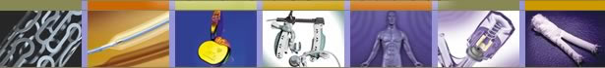

Design of a Pre-clinical Fluoroscopic Flow Model

For Intravascular Device Testing and Training

Guidant, Vascular Interventions
Basement BioWorks

Midterm Report, Spring Quarter

ME 382B: Biomedical Device Design and Evaluation II

Biomechanical Engineering Division

Mechanical Engineering Department

Stanford University

May 9, 2003

Project Team: Teaching Team:
Federico Gutierrez Tom Andriacchi
Mitul Saha Mariel Fabro
Yong-Nam Song
Anna Timbie

Guidant Sponsors: Stanford Mentors:
David Wolf-Bloom Dr. Charles Taylor
Stephanie Sszobota Dr. Chris Elkins

I Executive Summary

The future development of medical devices is limited by the designer’s ability to accurately test and evaluate a product before it is used on human patients. The pre-clinical test methods currently available for product research and development and physician training are limited to animal testing and simple plastic models. Unfortunately, neither model is an accurate simulation of human in vivo operating conditions or cardiovascular disease. Additionally, animal testing is very expensive, unfeasible for high-volume physician training and raises ethical considerations.

As an alternative means of testing and training, the Vascular Intervention Group of Guidant Corporation has developed a Synthetic Arterial Model (SAM) of human anatomy. The Guidant SAM simulates the human vascular system from the knee to neck but currently lacks several significant features of true in vivo conditions. The addition of the following features would improve the clinical realism of the synthetic model and aid in physician acceptance:

- Pulsatile flow through the vasculature at physiologic pressure and flow rate
- Coronary artery and heart wall motion to simulate a beating heart

During the winter quarter, the team focused on establishing design specifications and generating concepts to incorporate these desired features into the SAM. A Harvard apparatus pump was chosen to create pulsatile flow through the arterial model. After modeling the vasculature as a RCR circuit, we determined the dominant factors affecting the pressure and flow rate within the SAM and tested our theories on a simplified arterial model. The team used a system of connectors and valves located at the distal ends of the aortic branch arteries to impose resistance to flow through the model and produce physiologic conditions.

Alongside the flow modeling, the team developed design concepts for the actuation of heart wall motion. In the spring quarter, we built a critical function prototype to demonstrate the possibility of producing biphasic heart motion using fluid-filled chambers. We also used this prototype to experiment with different configurations of the heart, aorta and pump. The team chose to decouple the heart and the arterial models by the using two separate pumps to drive the models and synchronizing their motion by means of an electronic control circuit. We then designed and manufactured a silicone prototype heart featuring a separate atrium and ventricle chambers that are alternately filled to produce biphasic heart wall motion.

Our flow model and beating heart design will be used by engineers at Guidant in the early stages of device design. The addition of a beating heart and physiologic pulsatile flow will give designers an improved understanding of the actual operating conditions a device will encounter in use. Providing this kind of feedback early in the design process can save time, money, and lives. The SAM model is also used as a marketing tool for physician training. The more clinically realistic the model, the more confidant physicians will feel about purchasing and using Guidant products.

II Table of Contents

I Executive Summary 2
II Table of Contents 3
III Background 4
Sponsor Background ………………...4
Clinical Background 4
Scientific Basis for Design 6
IV Design Requirements 13
Functional Requirements 13
Physical Requirements 15
V Design Development 16
Strategy 16
Final Design Description 17
Final Testing and Validation Results 41
Feedback Summary 48
Design Evaluation 49
Future Steps 50
VI Project Plan 51
VII References 52
VIII Appendices 53
Slides……………………………………………………………………………………53
Distributors……………………………………………………………………………57
Original Project Description………………………………………………………...58

III Background

Sponsor Background
Guidant Corporation is a world leader in the design and development of cardiovascular medical products. Guidant’s stated mission is to provide leading-edge technology to physicians and life-saving therapy to patients. Guidant devices are intended to help patients with heart disease return to active and productive lives as soon as possible.

Guidant was incorporated in 1994, and has grown to $2.7 billion in revenue and over 10,000 employees worldwide. Guidant corporate headquarters are located in Indianapolis, with major operations in California, Minnesota, Texas, Washington, Puerto Rico and Ireland. Guidant products are utilized by physicians, hospitals and patients through a global distribution and marketing network across North America, Europe, Asia, Japan, Australia, and Central and South America. Guidant sales representatives are recognized throughout the medical device industry for their clinical expertise and customer service.

The Vascular Intervention (VI) Group of Guidant Corporation is focused on developing improved treatment methods for coronary artery disease. The minimally invasive therapies pioneered by this division are developed to provide physicians new treatment alternatives for patients suffering from coronary blockages. This division offers a broad product line of stents and stent delivery systems. The VI group has operations is Santa Clara and Temecula, California as well as Houston, Texas.

Clinical Background
Minimally invasive surgery has become an increasingly popular option in the treatment of cardiovascular disease. The risk and recovery time from traditional open heart surgery are reduced by performing catheter-based surgery. A guide wire and catheter is inserted into the femoral artery advanced through the vascular system to the site of disease. Surgical tools such as angioplasty balloons can be deployed at the end of these catheters. Guidant Corporation has become a world leader in the field of cardiovascular medical devices for catheter-based surgery. But the development of the next generation of devices depends on how well the designers at Guidant can test and evaluate their products. Currently available test methods, including animal models and simple plastic models, have significant limitations. Neither model accurately simulates the human disease state or true in vivo conditions.

In recent years, Guidant has developed a Synthetic Arterial Model (SAM) for product development and physician training in their European Training Center. In the year 2002, over 1700 physicians used the SAM. The Guidant SAM is a simplified model of human anatomy from the knee to the neck. The SAM uses lubricious, tissue-simulating materials create a modular vascular model of the major arteries. The SAM is designed for “plug-n-play” with interchangeable arterial segments to replicate varying anatomy and disease states. The vasculature can be filled with water or blood at body temperature. The model is fluoroscopically compatible. The component materials have a radiopacity similar to tissue so that the surgical devices introduced into the model can be seen on x-ray.

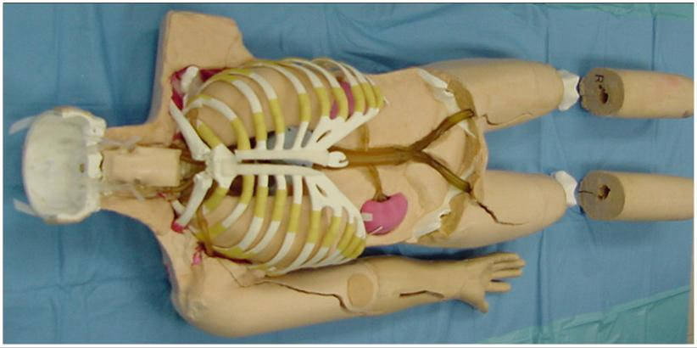

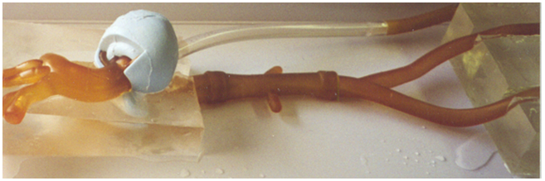

Figure 1: (Top) Synthetic Arterial Model integrated into phantom body
(Bottom) SAM aorta
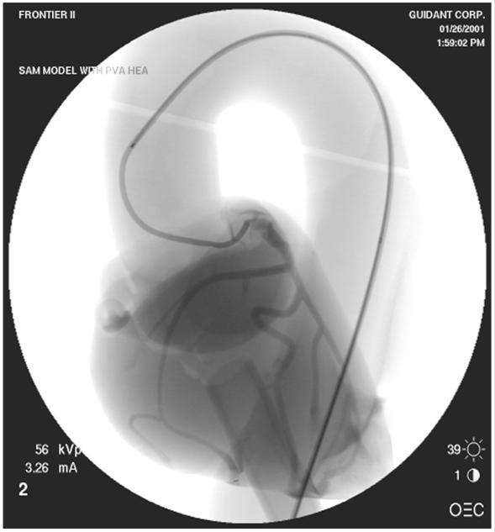

Figure 2: SAM heart under fluoroscope with contrast injected into coronary arteries

The Guidant SAM has many advantages over alternative pre-clinical models. However, the SAM lacks several necessary features to replicate in vivo conditions in human patients. These features include pulsatile flow through the arteries at physiologic pressure, a beating heart and respiratory motion. The incorporation of these features into the Guidant SAM would greatly improve the ability of Guidant engineers to evaluate their designs under surgical conditions. The improved clinical realism of the SAM would also increase physician comfort with the model and more importantly, Guidant medical devices.

Scientific Basis for Design
Our goal is to design a flow model similar to the human cardiovascular system so that it can be used for cardiovascular device testing and physician training.
The key scientific areas relevant to our project include:
- Cardiovascular flow modeling
- Heart wall motion (including stress-strain analysis for pressurized heart wall design)
- Fluoro-compatibility

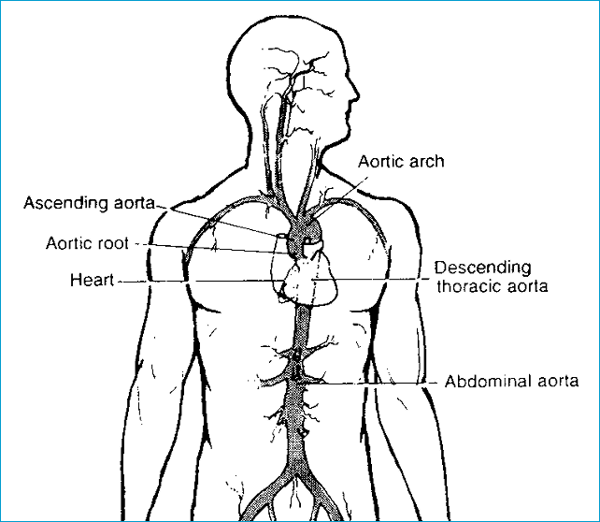

Figure 3: Human heart with the aorta

Cardiovascular flow modeling
The fluid dynamics of the cardiovascular system are extremely complex. Modeling it requires tools ranging from simple lumped parameters to sophisticated numerical techniques. Lumped parameter models based on an electrical circuit analogy provide a computationally simple way to obtain information about the overall behavior of the cardiovascular system. In these models, electric potential and current are analogous to the average pressure and flow rate, respectively. A particular vessel (or group of vessels) is described by means of its impedance, which is represented by an appropriate combination of resistors, capacitors and inductors. The resistors are used to model viscous dissipation, while the capacitors account for vessel compliance; the ability to accumulate and release blood due to elastic deformation. Finally, the inductors are used to model inertia terms. Regions of the vascular system can then be modeled and linked in a circuit network. These relationships are used to develop a set of nonlinear ordinary differential equations. As an example, the total resistance through a blood vessel can be computed by drawing an analogy between blood flow through an artery and current through a resistor.

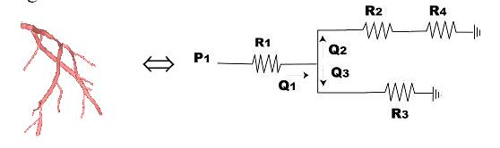

Figure 4: Analogy between blood flow through an artery and current flow through a resistor

If p is the pressure, Q is the flow rate through the vascular system, then the pressure drop and flow rate can related by:

Δp = QR ⇔ V =IR (Ohm’s Law)

Vessel compliance can also be modeled using a similar electrical circuit analogy. Consider the flow of blood into a compliant vessel.
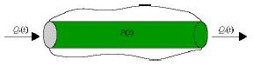

Figure 5: Flow of blood into a compliant vessel (Taylor, 2002)

If Q₁ is the input flow and Q₂ is the output flow, assuming a linear relationship, we have ΔQ = Q₁ – Q₂ = C dp/dt , where C is the compliance of the vessel. This is analogous to the governing equation of a capacitor, I = C dV/dt, where I is current and V is voltage.

Similarly an arterial tree can be modeled using the following RCR circuit:

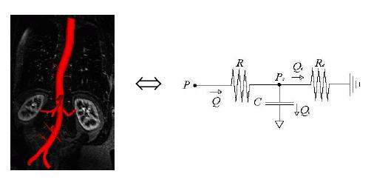

Figure 6: RCR circuit analogy for an arterial tree (Taylor, 2002)

Using the above analogies to electrical circuits, pressure and flow rates at critical points inside the arteries can be computed using elementary circuit analysis.

For the testing and validation of our artificial cardiovascular flow model the team used the chart shown in Figure 7. It depicts the arterial pressures and flow rates through critical sections of the human aorta (McDonald, 1974).
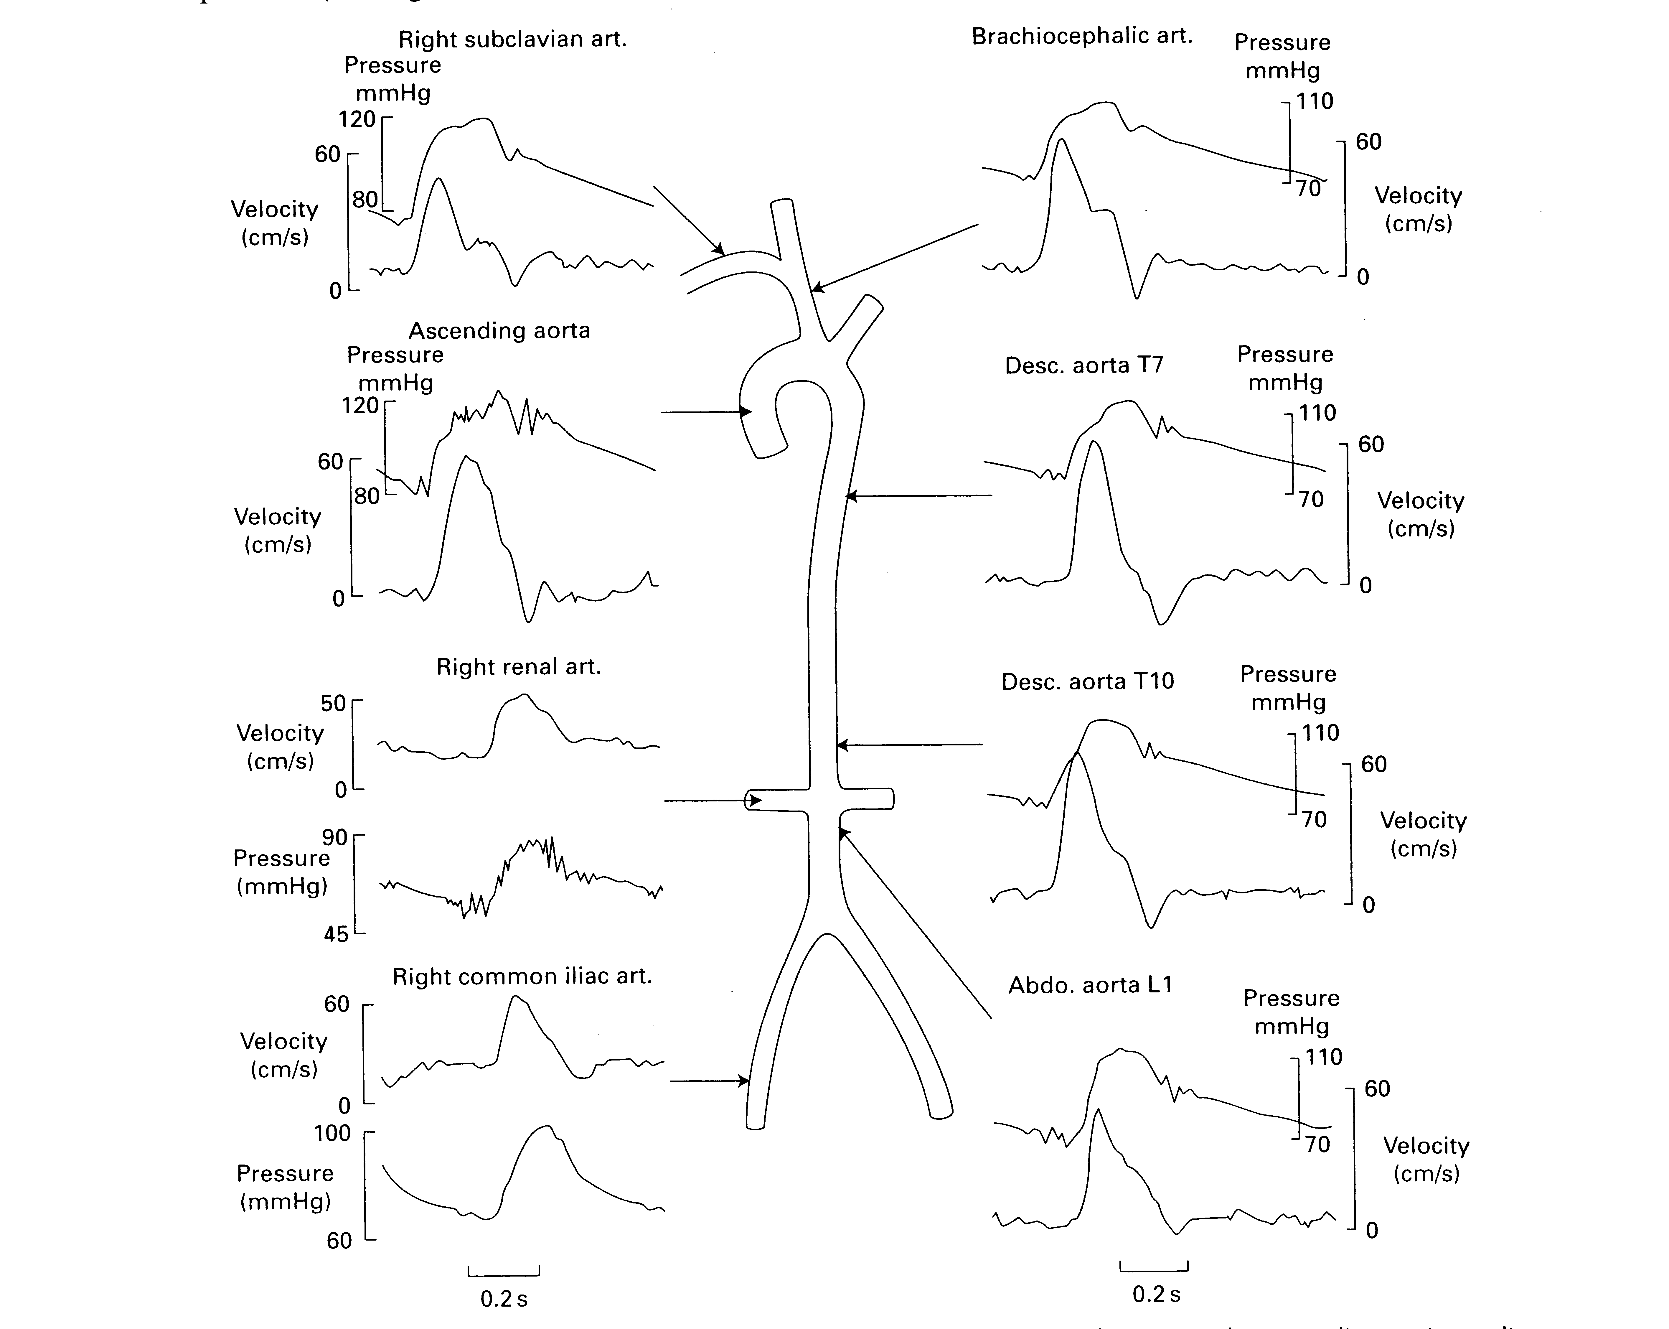
Figure 7: Target Values for Aortic Pressure and Flow Velocity
In our final prototype we aim to produce arterial pressures and flow rates within 10% of these published values. The exact shape of the waveform is not a critical feature of the Guidant model but physiologic realism is the ultimate project goal. Figure 7 shows a schematic of the target pressures and flow rates throughout the arterial model.

Heart Wall Motion
The heart prototype should also exhibit biphasic wall motion similar to a human heart. The human heart has four chambers; two atria and two larger ventricles. The biphasic motion results when the atria contract pushing blood into the ventricles, and thus expanding the ventricles. In our heart prototype we have combined the two atrium chambers into one common atrium cavity. Similarly, the two ventricles have been modeled as one cavity.

The coronary arteries sit on the heart as shown in Figure 8 and move with the heart walls. Our heart prototype should produce wall motion (biphasic contraction and expansion of the atrium and ventricle) such that the coronary arteries displace realistically.

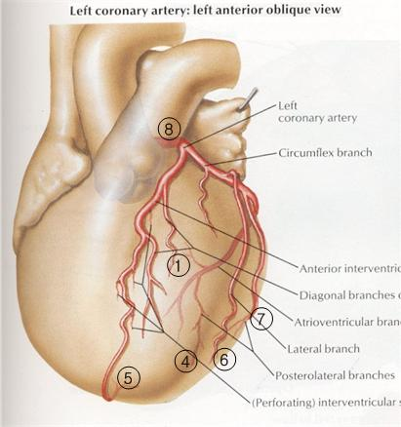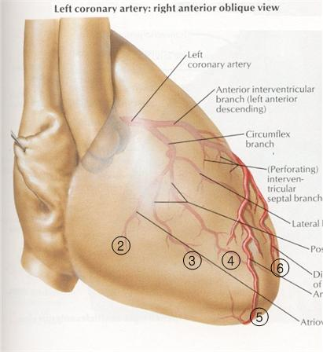
Figure 8: Coronary arteries attached to the heart wall

Figure 9 shows the 3-D images of the coronary arteries in systole (when the ventricles contract) and diastole (when the ventricles expand) created from an angiogram.

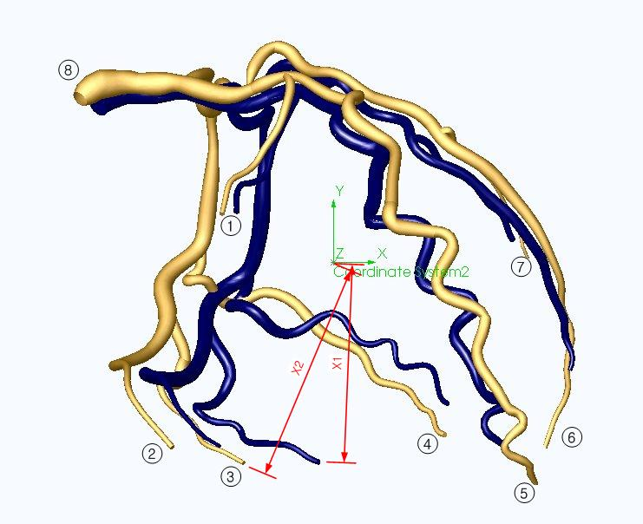
Figure 9: 3-D solid model of the coronary arteries. Blue vessels indicate position during end systolic contraction. Gold vessels indicate position during end diastolic expansion.

From the model we determined the percent displacements of some selected points (points 1-8 as shown in Figure 9) of the coronary arteries. Points 1,2,3,4 and 7 lie on the ventricle side-walls and displace due to the ventricle side-wall expansion. We used the average of the displacement values of these points as the parameter for the amount of ventricle side-wall expansion. Points 5 and 6 are near the tip of the ventricle. The average of the displacement values of these points was used as the parameter for the ventricle elongation. Lastly, the displacement value for the point 8 was used to approximate atrium expansion. The percent displacement values for selected points on the coronary arteries form the basis for the validation of the “realism” of our prototype heart wall motion.

Elementary plane stress analysis is useful for heart wall design and blood flow modeling. For example, a heart can be modeled as a spherical pressure vessel with radius r and wall thickness t subjected to an internal gage pressure p.

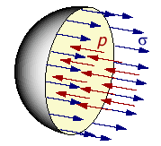
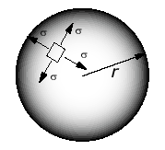

Figure 10: Pressurized spherical vessel (“Pressure Vessel”)

The stress around the heart wall must have a net resultant to balance the internal pressure across the cross-section. Therefore, the stress and the internal pressure can be related as:

σ t 2 Π r = p Π r²

⇒ σ = p r / 2 t

Similarly a blood vessel can be modeled as a cylindrical pressure vessel with radius r and wall thickness t subjected to an internal gage pressure p.

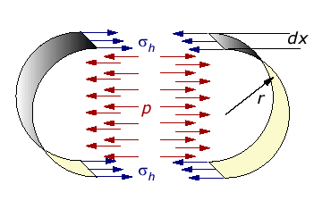

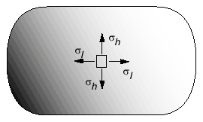

Figure 11: A pressurized cylindrical vessel (“Pressure Vessel”)

According to Newton's first law of motion, the hoop stress yields:
2 σ_{h} t dx = p 2 r dx

⇒ σ_{h} = p r / t

Fluoro-compatibility
The arterial model will be viewed under a fluoroscope during the testing of cardiovascular devices. Fluoroscopy is a means of visualizing moving body structures, similar to an x-ray "movie." During fluoroscopic examination a continuous x-ray beam is passed through the object of interest and is transmitted to a monitor to be viewed in real time. In cardiac catheterization, fluoroscopy enables the physician to see the flow of blood injected with a contrast agent through the coronary arteries in order to examine the presence of arterial blockages. During intravenous catheter insertion, fluoroscopy assists the physician in guiding the catheter into a specific location inside the body.

IV Design Requirements

Functional Requirements
The goal of our project is to incorporate new design features into the existing Guidant SAM to improve the clinical realism of the model. It is of critical importance to Guidant that the model includes the following:
- Pulsatile flow through the vasculature
- Realistic flow rate and pressure in the major arteries
- Heart wall motion
- Synchronization of the heart beat and the pulsatile flow

The pulsatile flow will be produced by a Harvard Apparatus pump. Both the stroke rate and volume of the Harvard pump can be adjusted to simulate realistic cardiac output. The team seeks to produce arterial pressures and flow rates within 10% of published values taken from Blood Flow in Arteries (McDonald, 1974). The pressure and velocity waveforms in the major arteries are shown in the diagram below.
Figure 12: Target Values for Aortic Pressure and Flow Velocity

The exact shape of the waveform is not a critical feature of the Guidant model but physiologic realism is the ultimate project goal. The project sponsors are interested in design recommendations regarding the use of capacitance elements exterior to the model that are necessary to produce an accurate waveform but it is not an express design requirement.

The design requirements regarding heart wall motion are more subjective. The goal of realism requires that the beating heart display life-like biphasic motion. Since it is only the coronary arteries that can be visualized with contrast under fluoroscopy, the beating of the heart must produce realistic displacement of the coronary arteries. To validate this design requirement, the team will use visual comparison to angiogram movies and spline models of the beating heart. The team has also acquired 3-D images of the coronary arteries in systole and diastole created from an angiogram, shown in Figure 13.

The 3D images were loaded into SolidWorks and a quantitative analysis was done to determine the displacement of the vessels. The origins of the two images seen below were first superimposed in an assembly file. A new origin was placed at the approximate centroid of the heart to determine the percentage the heart wall had expanded. By measuring the magnitude of a vector from the origin to the end of each vessel, in both systole and diastole, it is possible to extract the percentage that artery has moved. This is seen in Figure 13. By mapping each of the eight points onto a rendering of the coronary arteries on the heart, we can correlate the motion of each artery with a section of the heart as seen in Figure 14.

Figure 13: 3D solid model of left coronary arteries.
Blue vessels indicate position during end systolic contraction.
Gold vessels indicate position during end diastolic expansion.

Figure 14: Mapping of coronary arteries from solid model onto anatomically correct illustration of the human heart. Numbers correspond to vessel end points in solid model.

Area | Systole | Diastole | displacement | % disp
1 | 0.6672 | 0.7780 | 0.1107 | 16.5919
2 | 1.0203 | 1.0884 | 0.0681 | 6.6716
3 | 0.9463 | 1.0884 | 0.1421 | 15.0198
4 | 0.9590 | 1.0817 | 0.1227 | 12.7925
5 | 1.6277 | 1.6935 | 0.0658 | 4.0441
6 | 1.1392 | 1.2305 | 0.0913 | 8.0105
7 | 0.7929 | 0.8819 | 0.0890 | 11.2264

Table 1: Data from 3D solid model representing the displacement of the vessels during diastole

Physical Requirements
It is necessary that the mechanism used to achieve heart wall motion be fluoro-compatible (a radiopacity similar to tissue) so that medical devices advanced into the coronary arteries can be seen on x-ray. The beating heart model must be approximately life-sized to fit into the space available in the chest cavity of the SAM. Our sponsors requested that we increase the size of the heart from the solid heart model currently used in the SAM to create more space for the coronary arteries. The heart model must interface with the urethane aortic tree model and PVA coronary arteries fabricated by Guidant for the SAM.

Additionally, our project sponsors would like all elements of the arterial model to remain modular so that different versions of the branching arties with simulated disease sites can be used interchangeably for testing.

V Design Development

Strategy
The goal of our project is to deliver to Guidant an improved version of their Synthetic Arterial Model. The original project description included the introduction of physiologically accurate pulsatile flow, heart wall motion and respiratory motion. However, due to the complexity of each desired feature, the team consulted with the project sponsors and decided to focus on the first two deliverables:
- Pulsatile flow at physiologic flow rate and pressure
- Heart wall motion producing coronary artery displacement

During the winter quarter, the team developed an analytical model of flow through the arterial model to gain insight into the regulation of pressure and flow rate through the SAM. Then we began to experimentally develop a flow regulation system using equipment available in Dr. Charles Taylor’s lab. This required developing a system of distal valves at the vessel outlets to regulate flow through the vasculature as well as connecting the model to a data acquisition system to measure pressure and flow velocity. The preliminary experimental data was very encouraging; we were able create physiologic pressures inside the aortic model. In addition to flow modeling, the team began to brainstorming mechanisms to produce heart wall motion. We then refined and evaluated alternative heart designs and presented the most promising ideas to our Guidant sponsors.

Based on the positive sponsor response to the beating heart designs, the team built a critical function prototype in the spring to demonstrate the ability to produce biphasic motion using expandable, fluid-filled chambers. We also explored alternative system configurations of the pump, heart prototype and arterial model. Ultimately, we decided to decouple the beating heart and the arterial model by using two pumps. This required developing an electronic control circuit to synchronize the two independent systems.

Finally, we refined the aortic model by building converging networks on the branch vessels, placing distal resistors at the network outlets and repairing leaks in the model from the manufacturing process in order to determine the final valve setting recommendations. At the same time, we created a SolidWorks model of the beating heart prototype and then had the model parts 3D-printed. These parts were then used to create flexible molds and cast the final heart prototype at the Guidant facility in Santa Clara. While the heart models were being fabricated, the team constructed and tested the control circuit to synchronize the heart and the aortic model. The final step was to integrate the three project components; the arterial model, the beating heart and the control circuit.

Final Design Description

Arterial Flow Model
The arterial model that the team received from Guidant at the beginning of the project included a soft urethane aorta with renal, iliac and coratid arteries and a set of PVA coronary arteries. Designers at Guidant had been using the arterial model by perfusing it with steady flow at well below physiologic pressure. When we increased the pressure inside the arterial model, many unforeseen problems from component connections and the manufacturing process arose. Some of these new problems fell outside the scope of the project description but they all had to be addressed in order to proceed with the development of the pulsatile flow regulation system. Once the model was adapted, we took accurate measurements and determine the final valve settings for producing life-like conditions throughout the model. The main issues to be resolved were:
- Attaching the coronary arteries to the aortic take-offs
- Valve placement on the branching arteries
- Harvard Pump settings

Coronary arteries
Guidant designed the base of coronary artery to have an inner diameter slightly larger than the outer diameter of the coronary take-offs on the aortic arch so that the arteries would simply slip over the take-offs. At low pressure, this attachment method worked but at physiologic pressure the coronary arteries slid right off the aorta. The team’s first solution was to use the same plastic clamps used to connect sections of rubber tubing to hold the two together, but the coronaries still slid off the aorta under high pressure flow. So the team consulted with the project sponsors at Guidant and decided to sacrifice the modularity of the coronary arteries (the “plug-n-play” ability) and permanently glue a right and left coronary artery to the aortic tree. This solution looked promising for several days after gluing until the glue caused the model to dry out and crack during use. The PVA coronary arteries tore and, more significantly, the coronary take-offs on the aortic model were also damaged. The team was able to acquire from Guidant an additional aortic tree but it lacked any of the branching arteries included on the aortic model we were currently using. Rather then remove and replace all of the branching arteries, the team decided to remove the end of the aortic arch containing the coronary take-offs from the new model by cutting along a seam and glue it to their existing model.

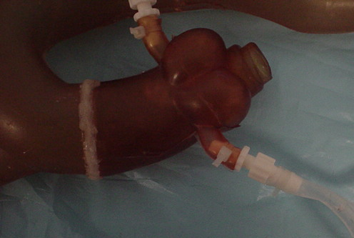
Figure 15: Aortic model with new coronary take-off section

The polyurethane used to make the aorta glues to itself quite well using urethane specific glue. The seal between the new segment of the aorta and the rest of the existing model has proved very solid. We have never experienced leaks at the seam and experimental measurements of the magnitude and shape of the pressure waveform in the aortic arch before and after the transplant indicate that we have not significantly changed the material properties of the aorta.

After repairing the aorta, the team decided to attach the coronary arteries using plastic connectors shown below.

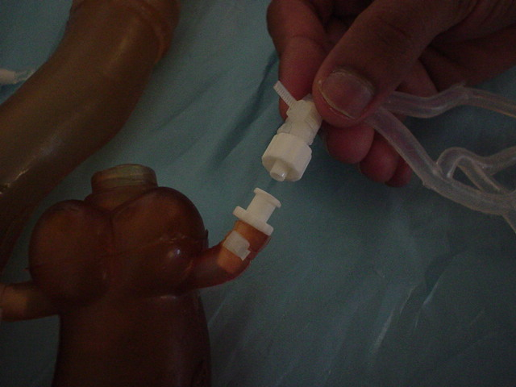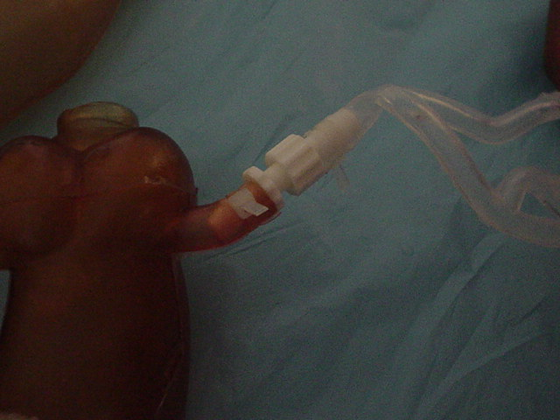
Figure 16: Connection between aorta and coronary artery

The connectors fit into the coronary artery and the coronary take-off and screw together to form a seal. The use of the connectors introduces a short section of rigid vessel with the slightly smaller inner diameter. The team has chosen to accept this deviation from tissue-simulating materials and small loss of compliance because of the difficulty in attaching the coronaries by any other means. The interface between the aorta and the coronary arteries is a problem acknowledged by Guidant. There is currently a design team at Guidant working to develop a better connector. Any progress they make could easily be incorporated into the work done by the Basement BioWorks team. This attachment method was never part of the project goals defined by the team and we chose to proceed with this non-ideal connection.

Valve Placement
Another important step towards finalizing the model was moving the valves used to create resistance through a vessel outside of the field of view of the fluoroscope. The fluoroscopic field of view is basically the area of interest during a surgical procedure. The field of view for the renal and coronary arteries is outlined in the pictures below. One can see a flow restriction valve around the renal artery, inside the field of view. This would appear as an opaque area under fluoroscopy and obstruct the view of any surgical devices being used inside the model.

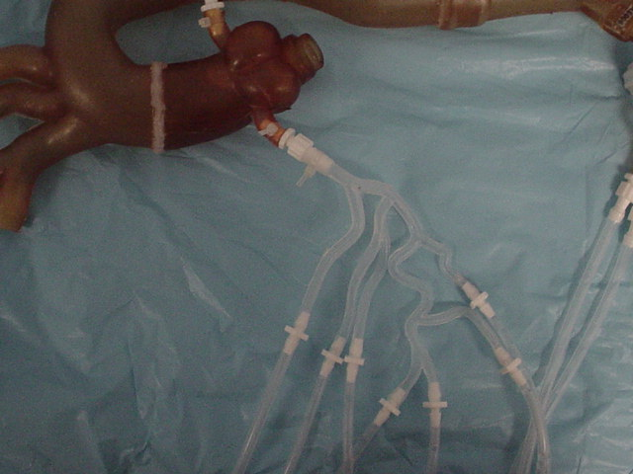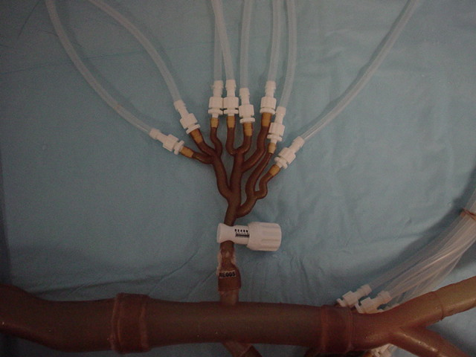
(A) (B)
Figure 17: Fluoroscopic field of view (A) PVA coronary arteries. (B) Renal arteries prior to change in valve placement.

The valves were moved out of the field of view by creating converging flow networks from the arterial branches using a series of “Y” connectors. The flow restriction valves were then placed at the end of the network.

.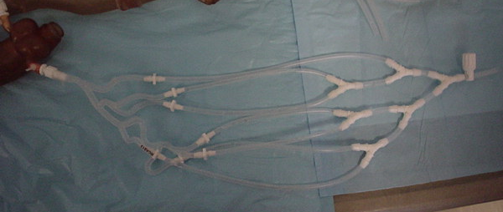
Figure 18: Converging flow network with valve

The converging network also allowed for much more accurate velocity measurements using an in-line flow meter following the valve and the ratio of the cross-sectional areas to determine the velocity in the artery. Before the networks were in-place, velocity measurements were made by capturing the flow out of all of the arterial branch vessels over a period of time. Using the flow meter, we can continuously visualize the velocity profile while adjustments are made to the valve settings allowing for much faster tuning than the iterative, “guess and check” method.

The full arterial model is shown below.
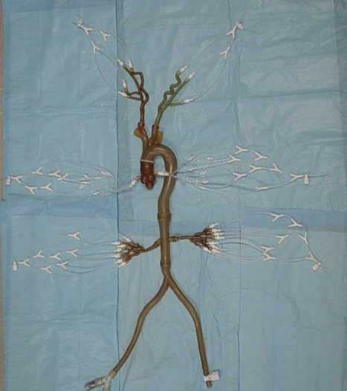
Figure 19: Arterial Model with networks and distal valves.

Harvard Pump Settings
The team also had to determine what standard set of operating conditions we would define as “physiologic” for the remainder of testing. This involved selecting settings for each of the three variables on the Harvard Apparatus, the pump used to produce pulsatile flow. These three variables include, stroke rate, stroke volume and stroke ratio (systolic/diastolic). The team has chosen to perfuse the model with pulsatile flow at
- A heart rate of 60 bpm
- A stroke volume of 55 ml/sec
- A stroke ratio of 40/60

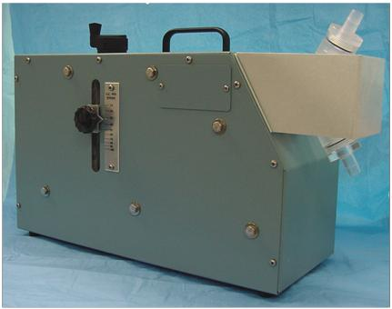

Figure 20: Harvard Apparatus

Beating Heart Prototype

Purpose
The other goal of this project is to create the physiologically realistic movement of the coronary arteries. Furthermore, the means by which this motion is created must not be visible under the fluoroscope. The team chose to produce this motion by using two fluid-filled, thin walled chambers. As the chambers fill with fluid, the walls expand and thus simulate the expansion of the heart chambers as they fill with blood. The expansion of the two chambers must also be offset from each other to simulate the biphasic motion of the heart.

There are many factors which affect the motion exhibited by the chambers. To better understand the system, our team designed and built a simple critical function prototype. Our main goals were to ensure that it would be possible to create the necessary biphasic motion by means of simple valve actuations and to determine what type of driving forces were needed to properly expand the chambers. Subsequent goals of the prototype were to define the effects of different system variables on chamber expansion. This information is useful when tuning the expansion of the chambers for improved realism.

Structure
The main components of the critical function prototype were two balloons of different wall thickness and internal space-fillers of different diameters. Each balloon represents two of the four chambers of the human heart. The smaller balloon represents the combined left and right atria of the heart while the larger yellow balloon represents the two ventricles of the heart. The atrial chamber actually consisted of two balloons fit around each other to create a thicker wall. Both chambers had an inlet and outlet tube attached using tube clamps or cable ties. This provided a quick-release method of fixing the tubes to the balloons. For this prototype, the quick-release allowed for a wide range of system configurations to experiment with chamber location and the variation of inlet and outlet diameters.
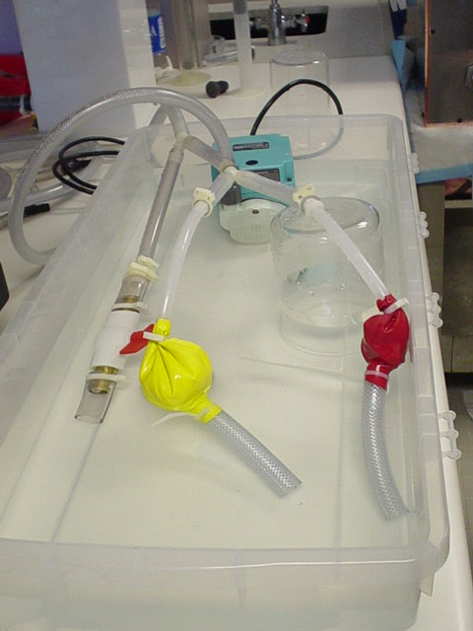

Figure 21: Experimental setup of the heart module critical function
prototype arranged with both chambers in parallel

This basic prototype allowed us to test various design concepts with the same basic hardware. Figure 16 shows the experimental setup of the prototype connected in parallel with a steady submersible pump. The functional prototype allowed the team to determine the affects of the following design parameters on the heart wall motion:
- Wall thickness
- Valve placement
- Tubing length and diameter
- Inlet/Outlet ratio

The wall thickness of the balloon chamber did not have a significant effect on the expansion and contraction rate. The size of the inlet and outlet diameter proved to be the dominant factor. The size of the inlet diameter determined the expansion rate as the balloon filled, while the outlet diameter determined the rate of contraction. The outlet diameter needed to be larger then the inlet diameter to simulate a realistic contraction. The optimal difference between the two was experimentally determined to be .25 inches. The team experimented with placing a valve between the atrium and ventricle chambers in a series configuration to create an offset in filling, but this did not prove to be necessary. Simply placing a length of tubing between the two chambers was sufficient to produce the desired phase delay. The length of the tubing determined the delay in ventricle filling. The team also experimented with placing the atrium and ventricle chambers in parallel and using exit valves to control filling. In this case, it was necessary to evenly divide flow from the pump between the two chambers or else one chamber would continuously fill. Out of all these configurations, the parallel heart configuration was the most successful at producing realistic, repeatable biphasic motion.

The final critical function prototype depicted above consisted of two single-balloon chambers connected in parallel to a submersible 500 gal/hour steady pump. This pump produces more flow than is required to drive the heart prototype so the excess fluid is diverted away from the model using a bleed valve. This was also useful for experimenting with the pressure inside the heart model. By partially covering the bleed valve it is possible to change the pressure inside the chambers. The outlet valves on both chambers are .25 inches larger in diameter than the inlet valves. For experimenting with the heart prototype, we controlled the chamber outlets by covering the tubing with our fingers rather than using valves or circuitry. This allowed us unlimited flexibility in the rate of filling and emptying.

System Configurations

Alongside the development of the functional heart prototype to produce biphasic motion, the team experimented with different system configurations to integrate the beating heart and the aortic flow model. We tried four different system configurations diagramed below. The ‘A’ and ‘V’ label the atrium and ventricle chambers of the heart respectively, and are inflated sequentially to create biphasic heart motion.

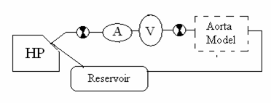
Figure 22: Pre-Aorta, Series configuration from Harvard Pump→heart→aorta

In the Pre-Aorta system configuration the heart model and the aortic model are placed in series, with the heart preceding the aorta. Check valves were placed before and after the heart to prevent back flow through the system and to attempt to isolate the aortic model from pressure changes in the heart.

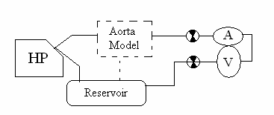
Figure 23: Post-Aorta, Series configuration from Harvard Pump→aorta→heart

This configuration is similar to the pervious series configuration except that the aortic model precedes the heart model.
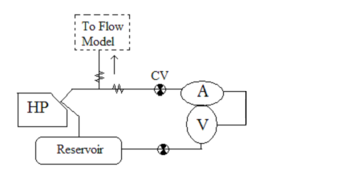
Figure 24: Parallel System, Flow from Harvard pump splits to heart and aorta

In the parallel system configuration, flow from the Harvard pump is divided evenly between the aortic model and the heart prototype. Check valves are used to prevent back flow through the system.

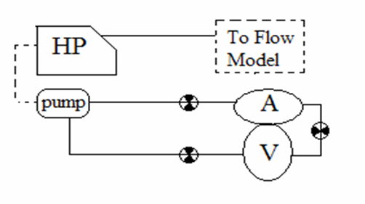
Figure 25: Two Pump System, The heart and aorta are decoupled

In the final system configuration, the heart and the aortic models are two independent systems. The aortic model is driven by pulsatile flow from the Harvard pump while the heart model is connected to a steady pump.

The team built these four system configurations using the preliminary aortic model and the functional heart prototype. Both series systems proved unfeasible because they could not produce sufficiently high pressures in the two elements. Using the Pre-Aorta configuration, a physiologic pressure of 120/80 mmHg could not be produced in the aorta. In the Post-Aorta system configuration, the pressure drop across the aorta proved to be large enough that the flow exiting the aortic model through an iliac artery did not have sufficient pressure to inflate the heart model. In the parallel configuration, the flow from the Harvard pump was divided between the heart prototype and the aorta and the volume was insufficient for reaching physiologic pressure in the aorta.

So the team chose to decouple the heart model and the aortic model and run the heart off of a submersible steady pump. The final design configuration is shown in the diagram below. The atrium and ventricle of the heart model are connected in parallel to the submersible pump. Two solenoid valves control the outlets of the heart chambers. The timing of the valve opening is controlled by an electric circuit which is triggered by a pulse from a switch placed inside the Harvard pump to indicate when the pump is at the forward limit of a stroke.

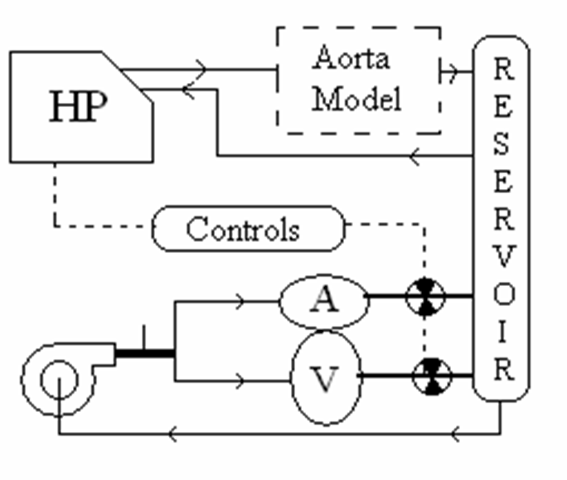
Figure 26: Final Two-Pump configuration

Heart Prototyping

Fundamental Concept
After creating and testing the critical function prototype, the design of the final heart prototype was initiated. The final prototype must contain components similar to those used in the critical function prototype, but have the appearance of an anatomically correct human heart. Therefore, our design must have two, thin-walled chambers stacked vertically (from a front view) with a separate inlet and outlet port for each chamber. This is shown in cross section in Figure 27.
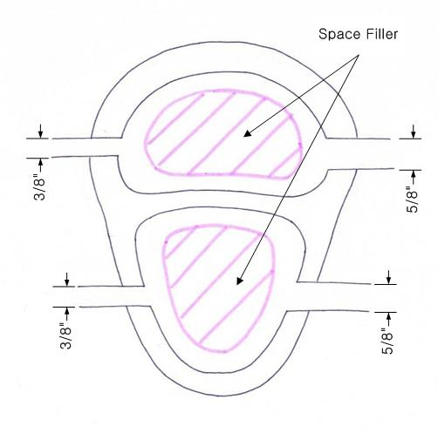

Figure 27: Cross section of the initial conceptual prototype for the Beating Heart

In our initial design concept, we planned on using space fillers inside the chambers to allow for greater expansion with less fluid flow, as shown above. However, this concept was generated with the idea that the system must minimize fluid flow since the Harvard pump would drive both the beating heart and aortic modules. By decoupling the two systems, the need to minimize flow through the heart was eliminated and consequently the space fillers were eliminated from the final design.

From the critical function prototype it was also discovered that the pressure to the heart model could be easily increased and decreased by adjusting the bleed valve output. Therefore, as opposed to designing around a given pressure, our team designed around the optimized inlet/outlet diameter difference of 0.25 inches. This allows for flexibility in both the thickness of the heart chamber walls and the materials used to fabricate the heart. For the first prototype a wall thickness of 1/8 inch was used for the ventricular chamber and 3/16 inch for the atrial chamber.

Solidmodeling
The human heart is a complex organ with various changes in curvature and surface properties. Consequently, this creates quite a challenge when attempting to replicate the heart in a three dimensional software package. There are, however, commercially available packages that have already created a geometric representation of the heart with great detail. Guidant has provided our team with a commercially available surface model produced by Viewpoint.

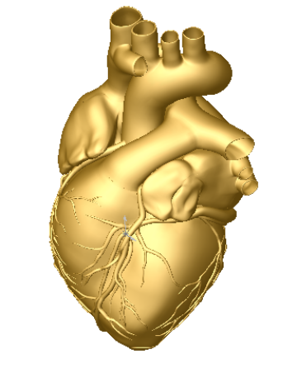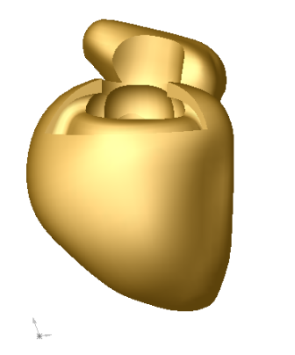
(A) (B)

Figure 28: (A) A front view of the Viewpoint surface model of the human heart.
(B) A view of the simplified model of the human heart provided by Guidant.

Unfortunately, this surface model is far too detailed for the purposes of this project. Furthermore, the high level of detail of the model resulted in various geometric errors when importing the file from Initial Graphics Exchange Specification (IGES) format into the 3D software. Therefore, a more simplified model of the heart was used. Guidant has also provided our team with a simplified heart model, which they currently use to fabricate the solid hearts used with the SAM. Using this simplified model also allows the interface between the heart and the aorta to remain unchanged. Most of our modifications to the model were to the inside of the heart. Therefore, the exterior shape of the final prototype closely resembles the geometry of the current Guidant heart.

Modeling
The Solidworks 2001 three dimensional solid modeling software package was used to make our modifications to the heart model. The base model for the heart is shown above in Figure 28(B). This model was modified at the beginning of the SAM project by Guidant. The right atrium was removed and the posterior and anterior sections of the right ventricle were slightly indented.

For the purposes of our model, the right atrium would be re-introduced and the right ventricles would be modified to resemble their previous shape. The first step in the modeling process was to section the heart into three main modules consisting of:
- The two atrial chambers
- The mid-section which would interface with the aorta
- The two ventricular chambers

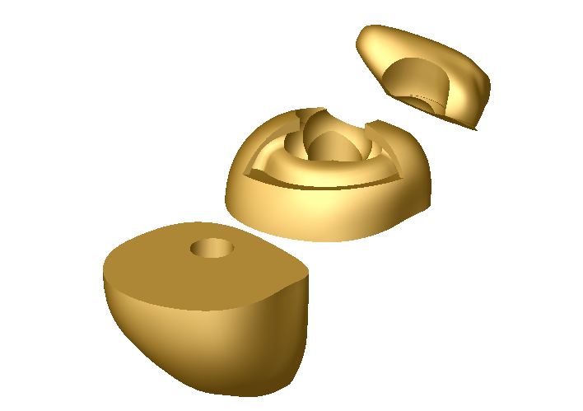
(2)
(3)
(1)
Figure 29: Exploded view of simple heart model after initial sectioning

This sectioning allowed for each piece to be worked on independent of the other sections. Section (1) consisted of various undercuts and sharp geometry, which made it almost impossible to work with. Therefore, the single atrial chamber was replaced by a two-chamber atrial assembly. Using the guide contours of the original atrium, a new atrium solid was created. This chamber has a larger cross section of approximately 2 inches and was shelled with a wall thickness of 0.125 inches. The original design was for a wall thickness of 3/16 inch but due to the geometry of the chamber, the thickness was limited to 1/8 inch.

Section (2) is critical because it is the interface with the aorta. Therefore it must be able to hold the aorta in the same position each and every time. Guidant has done an excellent job in creating this interface and the team decided, if at all possible, to limit the modifications to this section. Therefore, the inside surfaces were left alone while the outer surfaces were thickened to match the modifications to Section (3). This also allows us to leverage the existing coronary artery interface.

Section (3) consists of the chamber representing the two ventricles. The surface of this section was first straightened by importing the model section into the Rhinoceros 3D modeling software. The B-spline curves were slightly modified to remove the curvature from the anterior side. We also attempted to enlarge the right ventricle but our modifications were limited by geometric constraints. The section was re-imported into Solidworks and the surfaces were thickened and joined as a single section. This created a hollow section with wall thickness of 0.118 inches. Again, the wall thickness of this chamber was limited by its geometry.
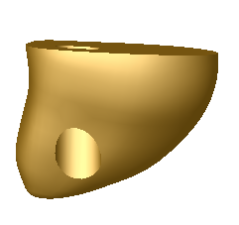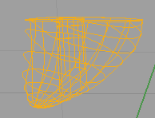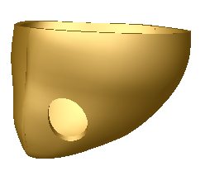

Figure 30: Removal of “indentions” in Section (3) by modifying the B-spline curvature

After being processed individually, cores were created for both chambers for use during the manufacturing process. The sections were then joined in an assembly file. Due to the modifications on the surface of the ventricles, Sections (2) and (3) had to be lofted together to compensate for the mismatch in curvatures. Figure 31 shows the final model joined together as one part.
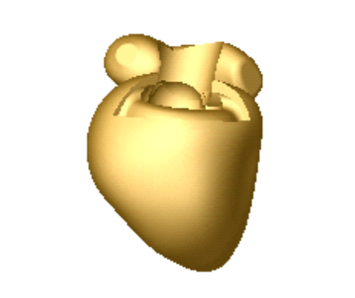
Figure 31: Solid model of heart prototype

Fabrication of Prototype
Since our beating heart prototype closely resembles the existing SAM heart, we are able to leverage a large portion of the current manufacturing process. The current SAM hearts are created from either silicon or urethane based material. Regardless of the material chosen, a common set of molds and cores can be used to produce different models.

Guidant has developed a five-step process to fabricate their SAM heart models. This process cleverly utilizes the outer surface of the model as a means to secure the coronary arteries to the heart wall. As seen in Figure 32, the final SAM heart model contains multiple grooves, which the coronary arteries fit inside of. This layer is known as the “myocardium.” These grooves can be modified from model to model depending on the specific focus of each experiment conducted with the SAM. Our team leveraged most of this manufacturing process, only slightly varying a couple of steps to incorporate our design changes.
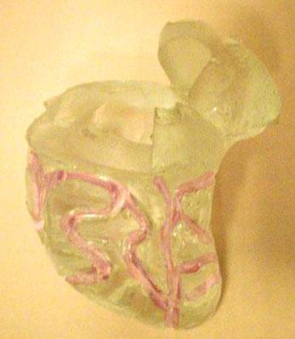

Figure 32: A side view of the original SAM heart model with coronary grooves highlighted.

In order to create this synthetic heart, multiple model positives must be first created. Using the final model described in the previous section, four other parts are created. By enlarging and reducing the size of Section 3 of the model, we were able to create the “enlarged heart” and the “reduced heart.” The reduction was done by scaling Section (3) down by a factor of 0.87. This allows for a 0.32 inch myocardial layer to hold the coronary arteries.

Similarly, using Section 1 and 3, an inner core was created for the atrium and ventricular cavities. This cores are responsible for creating the inner cavities of the model. To ensure proper alignment of each core, a series of core registration pins was added to each of the models. The pins serve a dual purpose. They act to align and hold the cores in place and create the holes for the inlet and outlets of the chambers. The largest pin on the ventricles is used to pass a tube that will later connect the root of the aorta to the Harvard pump. All five models are illustrated in Figure 33. Figure 34 shows a cross section of the heart with the inner tube attached.

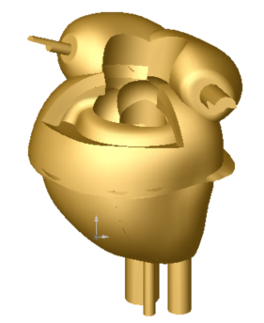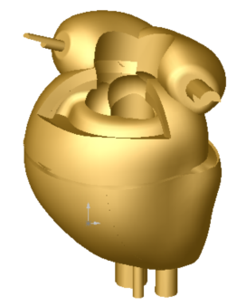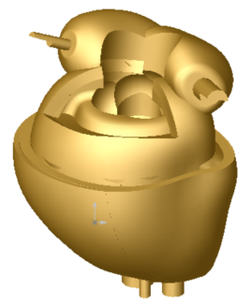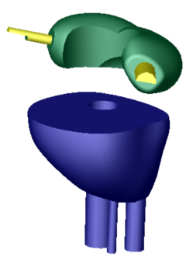
(A) (B) (C) (D)
Figure 33: Five models produced in Solidworks for use during the manufacturing process.
(A) Reduced Model (B) Full Model (C) Enlarged Model (D) Atrium and Ventricle cores.

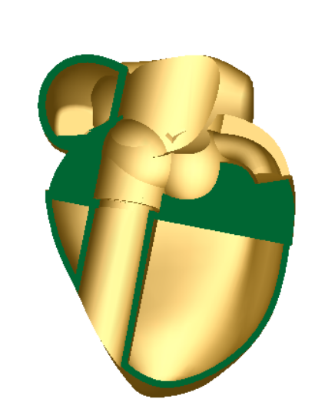
Figure 34: Cross section of a side view of the final heart solid model.

Originally these models were to be produced on a Guidant SLA machine in Temecula. However, due to file compatibility issues, we were not able to create the models by conventional SLA means. Therefore, the team turned to other methods of rapid prototyping. Three dimensional printing is a rapid prototyping method which uses a starch based powder to build 3D volumes. By printing thin layers of resin on a base of powder, similar to printing ink on a sheet of paper, a 3D printer can create a three dimensional part. The team outsourced these parts to Javelin 3D, a prototyping company based in Utah. The parts were created from a starch based power and infused with a urethane material to harden them and allow them to be used for creating molds. Figure 35 shows the 3D printed parts prior to the molding process.

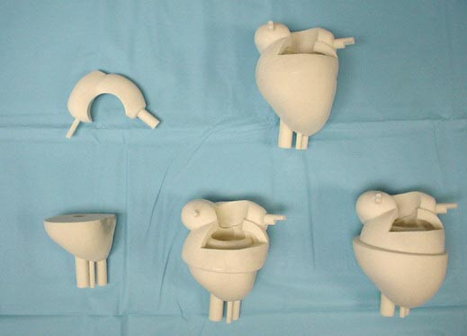
Figure 35: 3D powder printed parts prior to molding

The first step in this manufacturing process is to create a “master mold” which will serve as the casting platform for the heart. This master mold is created from the enlarged heart model. This mold is poured in four separate sections allowing each section to fully cure before the next is added. The first layer is a base layer which holds the heart in place. The second layer creates the lower half of the mold, which encompasses the enlarged ventricle section. The third layer covers the midsection of the heart up to the middle of the atria and creates the core geometry to interface with the aorta. The final layer covers the atria and creates the injection and vent holes for the mold. Ventilation, injection and clamping pins were added as needed.
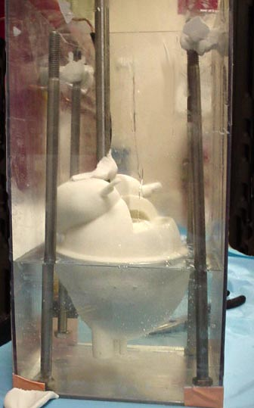
Skin Layer
Aortic Core Layer
Atrial Core Layer
Ventilation Pins
Base Layer

Figure 36: Master Mold with only the Skin Layer poured

Once this mold is created, the model is carefully removed from the mold. Next, a series of “skins” is produced which lie inside the Skin Layer of the master mold and are responsible for creating the geometry of the reduced and full sized heart. These skins will also be responsible for creating the grooves in the myocardium later. One at a time the other two models are placed into the lower half of the mold and the “skins” are poured from a TAP urethane material. This is illustrated in Figure 37. This manufacturing method allows from multiple model configurations to be created from a single master mold.

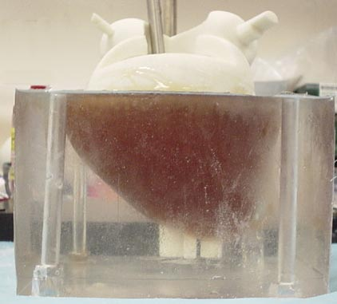
Figure 37: Casting of the TAP urethane skin

While these molds are being created, two separate molds are also created in parallel. These molds will create the water soluble wax cores. These molds are created in a similar fashion to the master mold but, they are only sectioned once. They are allowed to cure overnight and the models are removed in the morning. The cores are then cast from a water soluble jeweler’s wax.

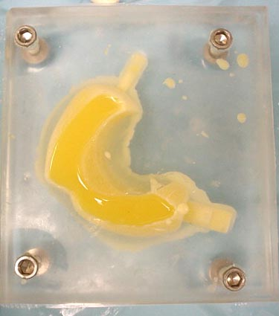
Figure 38: Wax casting of atrium core

Next, the master mold is reassembled with the two cores in place and the skin for the reduced heart. The reduced heart is then cast from a silicon material. We have chosen a silicon polymer known as Dragon Skin © which is produced by Smooth-On. This polymer has a Shore Hardness of 10 on a Shore A scale and is very durable with a large elongation to tear ratio of 1000%.

Once cured, the silicone reduced heart mold is removed from the mold and urethane coronary arteries are pinned to the ventricles. These urethane arteries will create the grooves in the myocardium in which the SAM arteries will be embedded. This allows the model to have modular, “plug-n-play” functionality. This is demonstrated in Figure 39

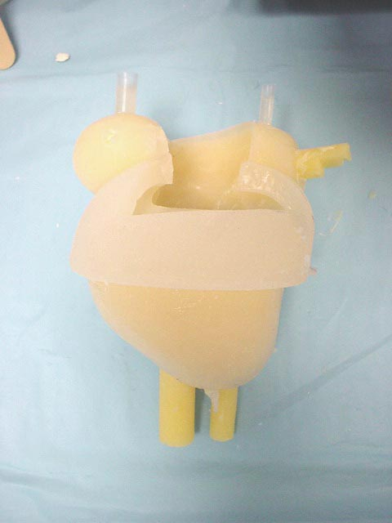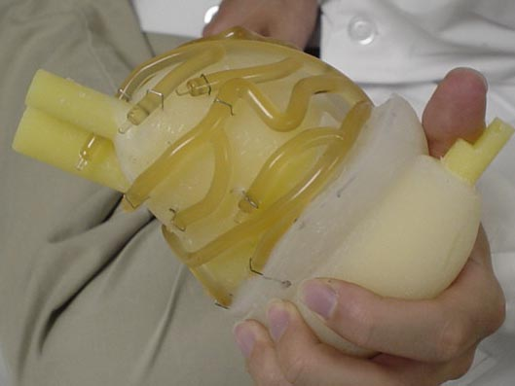
Figure 39: (A) Reduced silicon heart model (B) urethane arteries pinned to the reduced heart

This model is placed back into the master mold with the full skin in place and the final model is cast from the same silicon material. The model is allowed to cure for five hours and then removed from the mold.

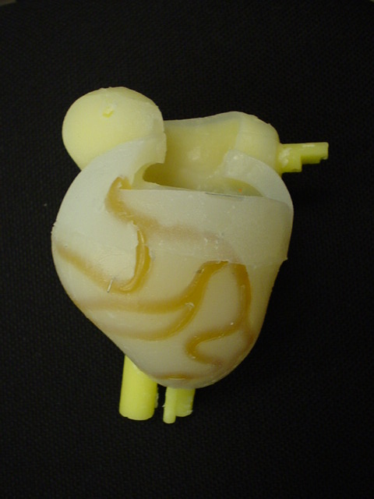
Figure 40: Full heart with cores and urethane arteries still embedded

The final steps are to remove the arteries and wax cores. A thin line was cut above the arteries to allow them to be removed. This creates the grooves to hold the coronary arteries in place during use. To remove the cores, the model is placed under running water until all the melted wax has been removed.

Once the final heart has been created, the inlet and outlet tubes were attached by applying a layer of silicon to the tube/heart interface. Silicon tubing was selected for this because of the amazing bonding strength of similar silicon based materials. Furthermore, the diameter of the holes in the heart is equal to the inner diameter of the tubing. This causes the material surrounding the tube to be compressed against the tube when it is inserted, thus helping seal the interface. The model was tested under normal operating conditions and no leaks were found. Furthermore, the heart was able to maintain the “plug-n-play” functionality because no adhesives were used to hold the aorta onto the heart. Figure 41 shows the finished heart attached to the aorta.

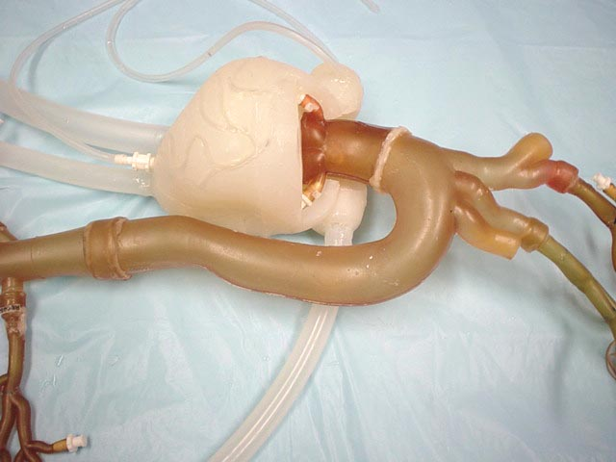
Atrial Outlet

Atrial Inlet
Ventricle Inlet
Ventricle outlet
Aorta Inlet
Figure 41: Finished silicon heart interfaced with the SAM aorta.
Red arrows mark heart system flow, blue arrows mark aortic system flow.

Synchronization Circuit: Heart Actuation

To achieve realistic heart wall motion the expansion and contraction of the heart chambers must be synchronized with the motion of the Harvard pump. It should appear as though the beating of the heart is pushing fluid into the aorta despite the fact that the two systems are independent. As the piston inside the Harvard pump moves forward, the atrium expands and ventricle contracts. Then when the piston moves backward, the atrium contracts and the ventricle expands. To produce this biphasic heart wall motion, we place two solenoid valves at the outlets of atrium and the ventricle. We can control the expansion and contraction of the two chambers by opening and closing these valves. When an outlet valve is closed, the preceding chamber will expand. When the valve is opened, the chamber contracts quickly because the outlet diameter is much larger than the inlet. An electrical circuit is used to synchronize the aortic model driven by the Harvard Pump and the beating heart model driven by a steady pump.

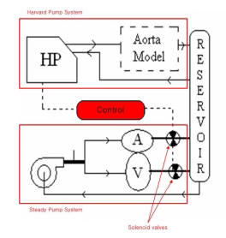
Figure 42: The synchronized aortic model and beating heart model

Electronic Control Circuit
The diagram below details the circuit used to control the outlet valves. This circuit consists of three major parts: The first part generates a clear signal, the second part creates a second signal and the third controls the opening and closing of the valves.

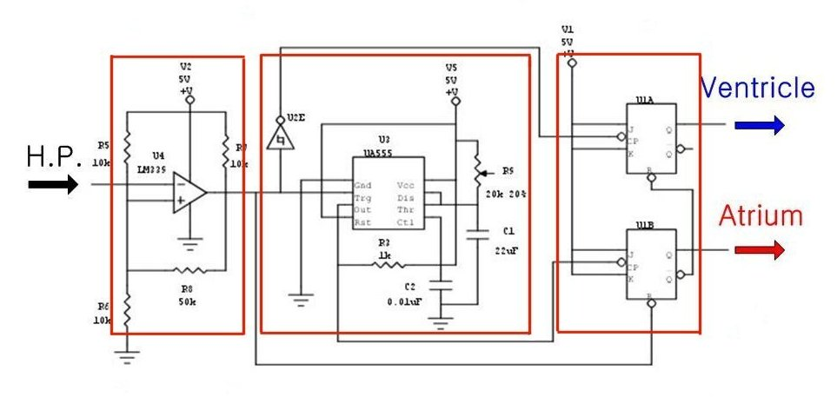
Figure 43: The electrical control circuit

The pulse from the Harvard pump is not clear enough to make logic high and low for electronic circuit. The pulse ranges from 1V to 3.5V. Because general electronic components consider a signal over 0.3V as logic high, this range is always considered high. To address this problem, we send the Harvard pump signal through an Op-Amp which is set to recognize only signals over 1.5V as a logic high signal. As a result, we get the 0V to 5V clear input signal for the control circuit.

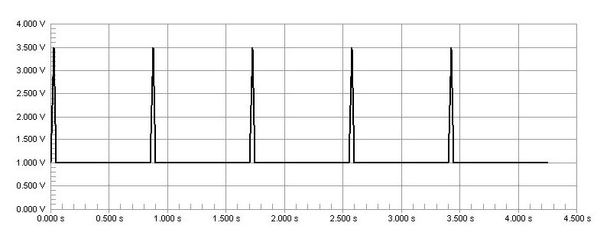
Figure 44: The signal from Harvard pump
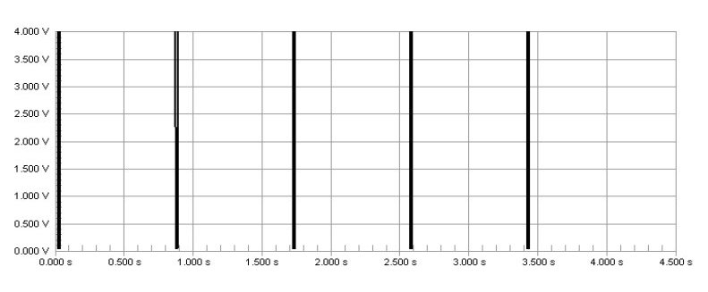
Figure 45: Clear signal after OP-Amp

A switch has been placed inside the Harvard pump to produce an electrical pulse when the piston is at the forward limit of a stroke. The control circuit receives this pulse signal directly from the Harvard pump and uses it as a source signal. Specifically, the falling edge of the pulse from the pump is used as the input signal.

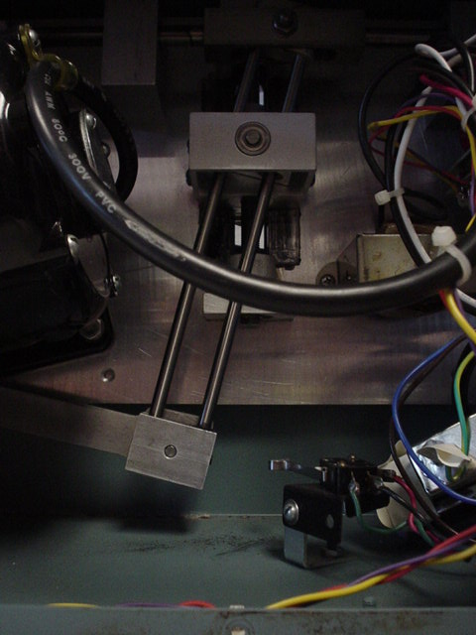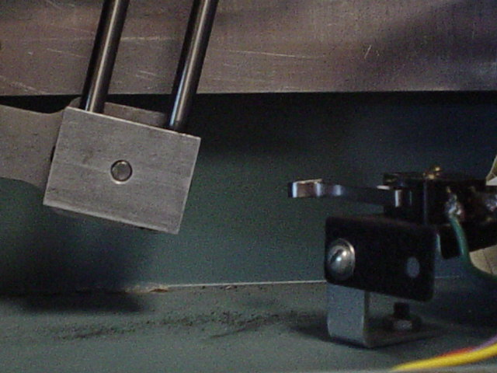

Figure 46: Switch inside Harvard pump
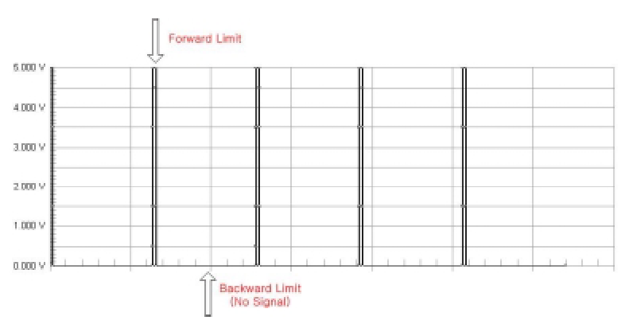
Figure 47: Unmodified signal from Harvard pump

Unfortunately, the Harvard pump only indicates when it is at the forward limit of a piston stroke. The heart actuation requires a trigger at the forward limit and the backward limit of a stroke. (Figure 47) Therefore, we need to create another signal at the backward limit of the pump stroke. This is the function of the first half of the control circuit labeled “Signal Creating”. By using a monostable timer circuit, we copy the input signal from the pump switch and extend the pulse duration time. As a result we can create another falling edge. We can also change the timing of second edge by adjusting the potentiometer (Ra) which allows us to control how long the atrium and ventricle expand during one heart cycle. We can calculate the time interval between the first signal and second signal using the formula below.

Time interval, T = 1.1 * Ra * C

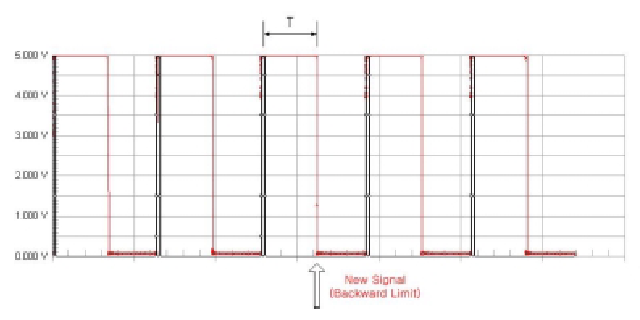
Figure 48: Harvard pump signal modified to produce two inputs

Biphasic Expansion and Contraction
The control circuit is made using two JK flip flops. These flip flops are triggered by the falling edge of a pulse and then maintain their current state until another falling edge appears. This produces the biphasic signal shown in the following diagram. A logic “high” signal means that the control valve is open and the chamber is emptying.
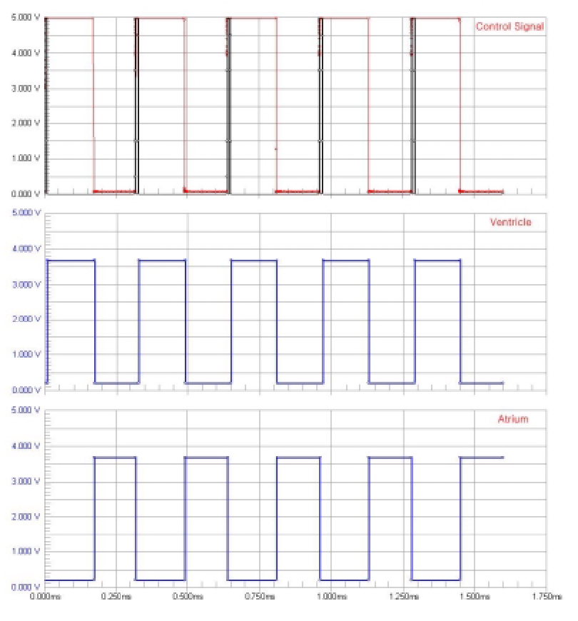
Figure 49: Signal inputs and valve positions

Control Box
To protect electronic circuit from water and allow for easy connection to the heart model, we build a control box. We placed the two solenoid valves and circuit board inside an acrylic box, forming one package. It has ON-Off switch and BNC connector sample the signal from the Harvard pump in front side.

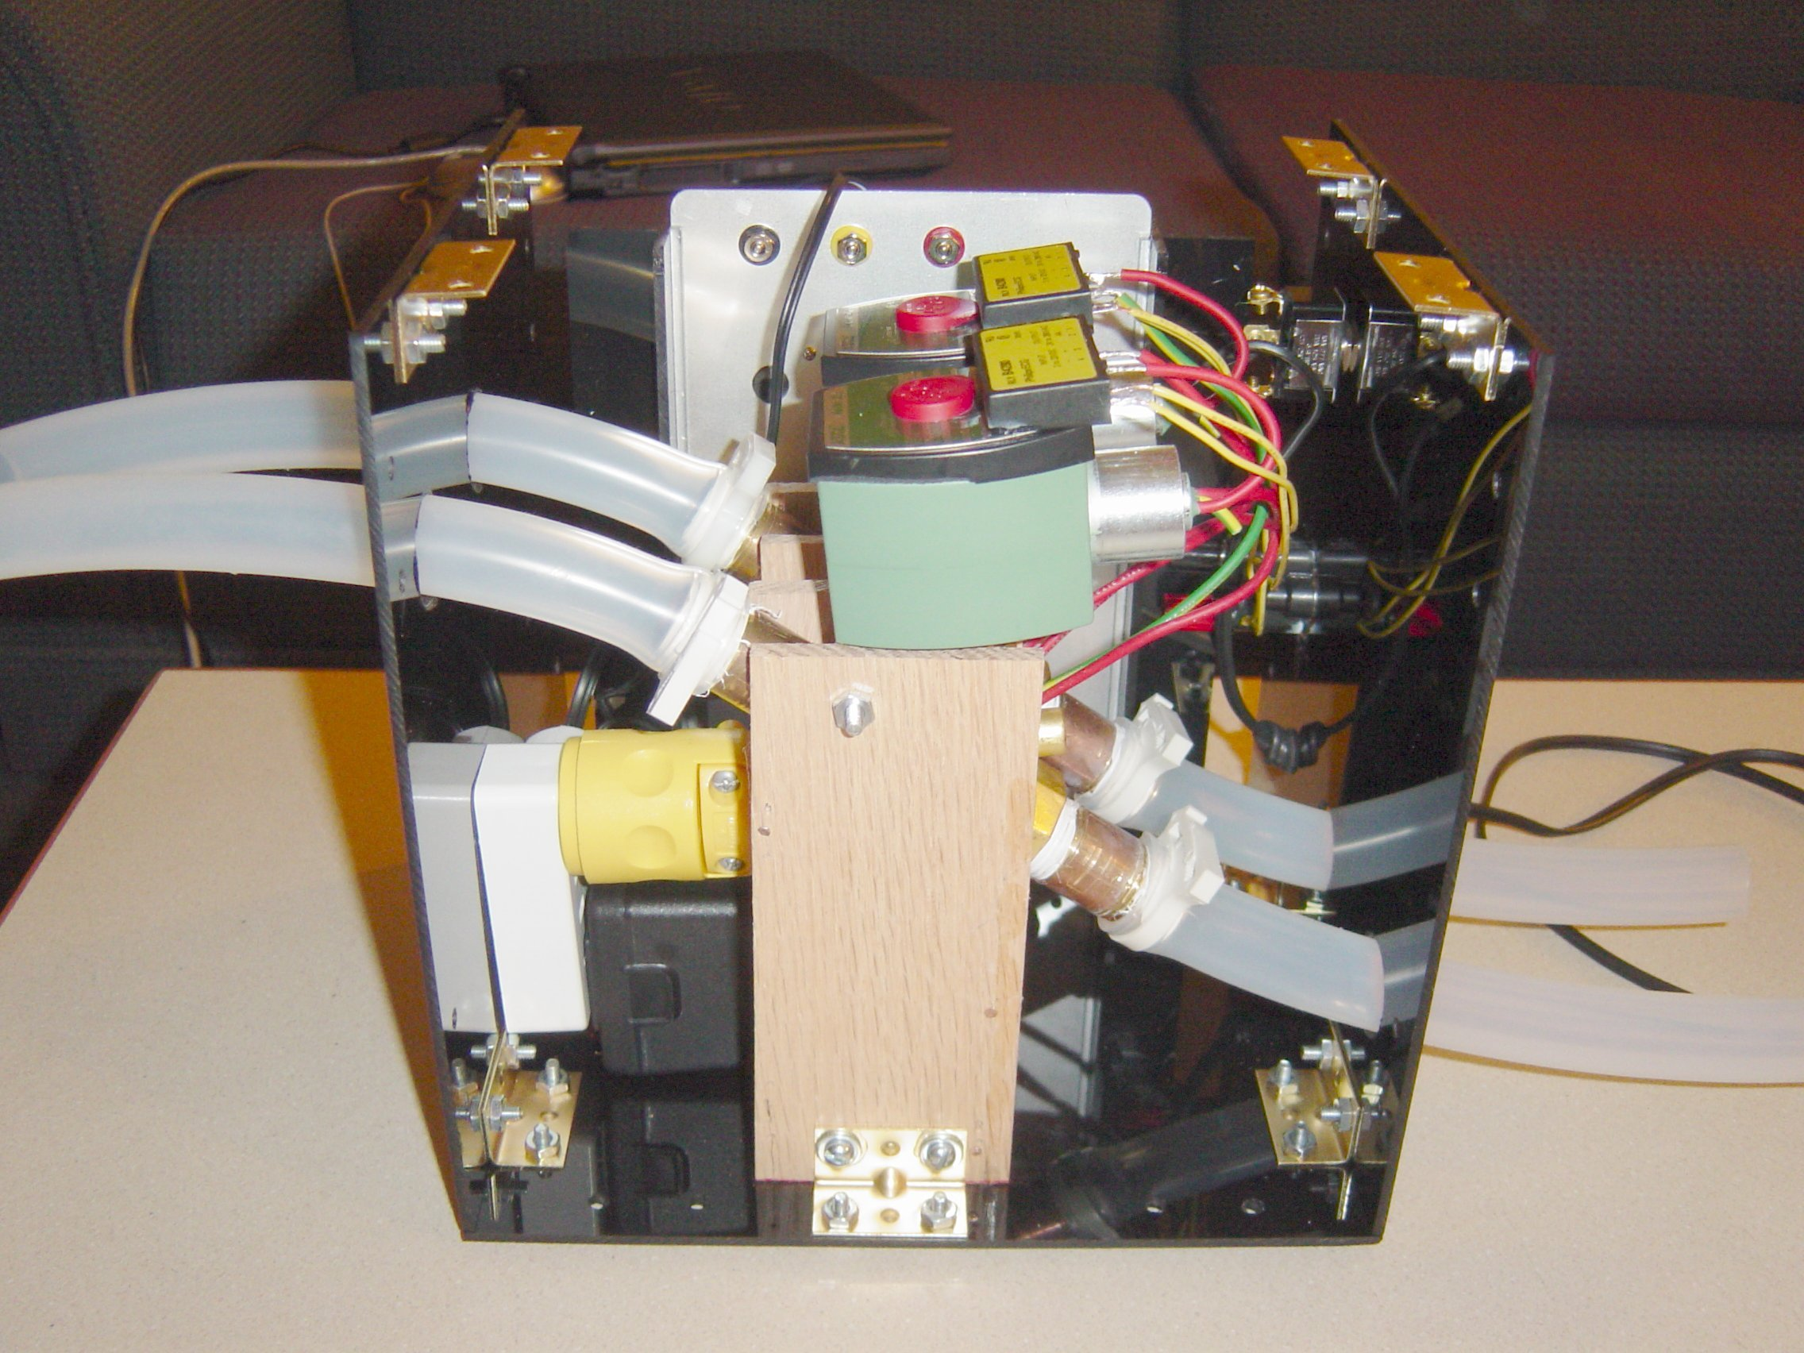
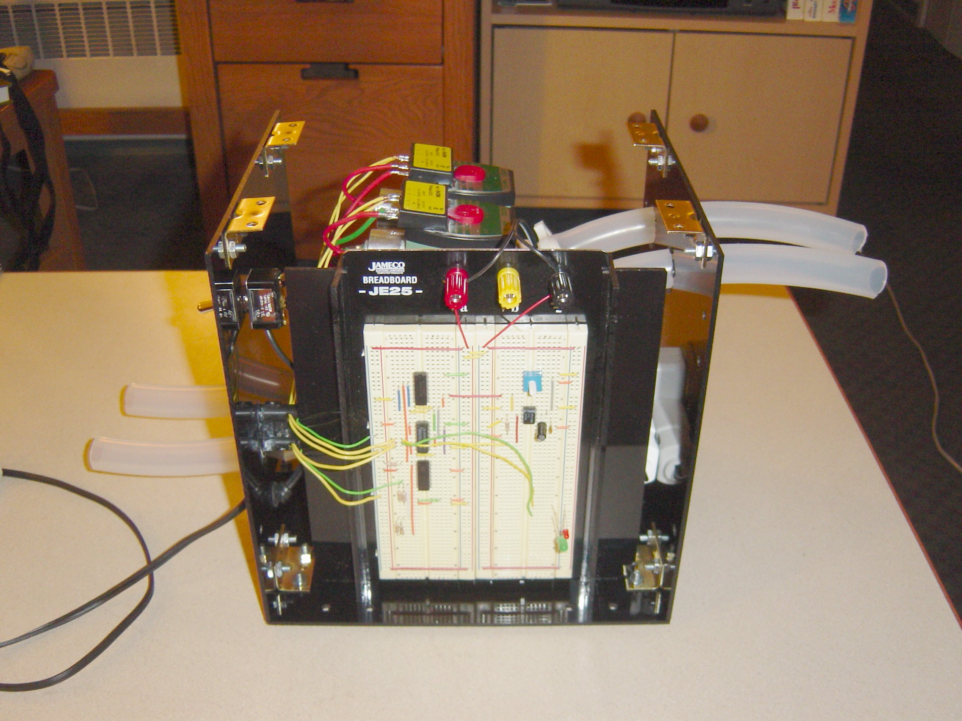
Electronic Circuit
Two Solenoid Valves
ON-OFF Switch
BNC Connector

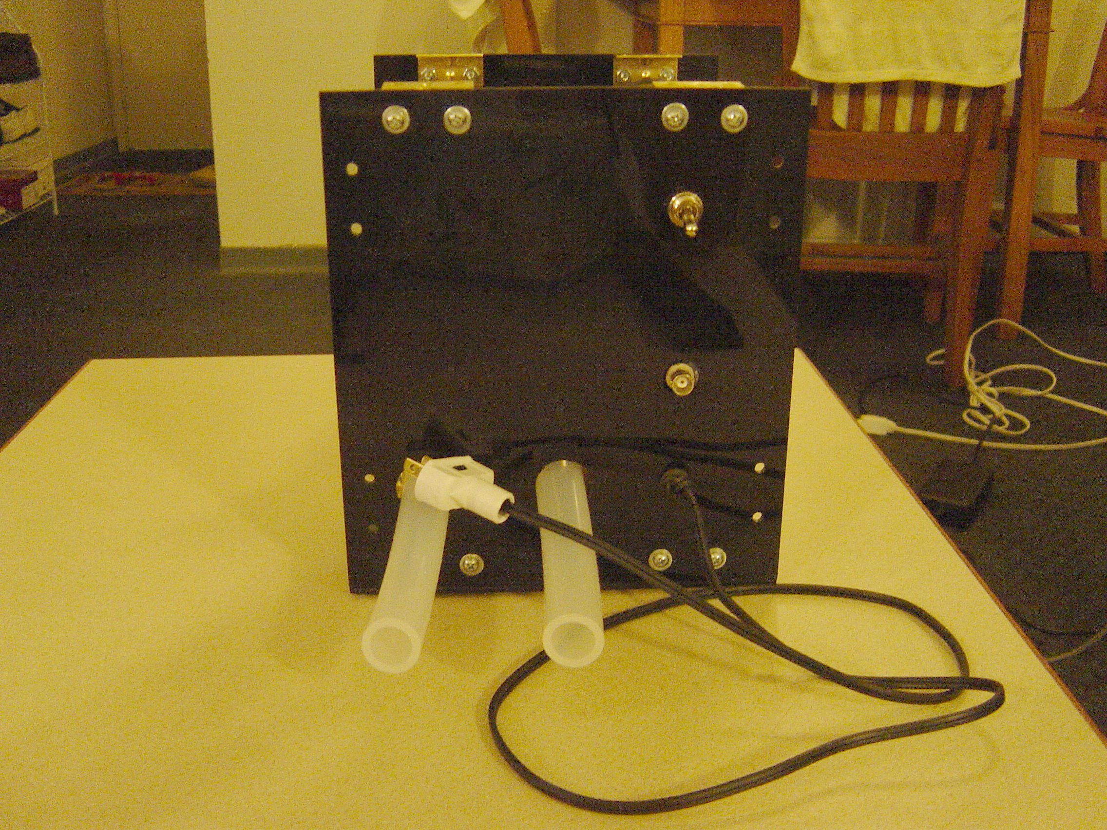

Figure 50: Control box

Final Testing and Validation Results

Arterial Flow Model
To develop the flow control valve system and verify that it produced physiologic flow conditions inside the arterial model, the team used a pressure catheter to sample the pressure inside the aorta and branch arteries. The catheter was introduced into the iliac artery and connected to a data acquisition system to display the pressure waveform and determine the mean pressure.
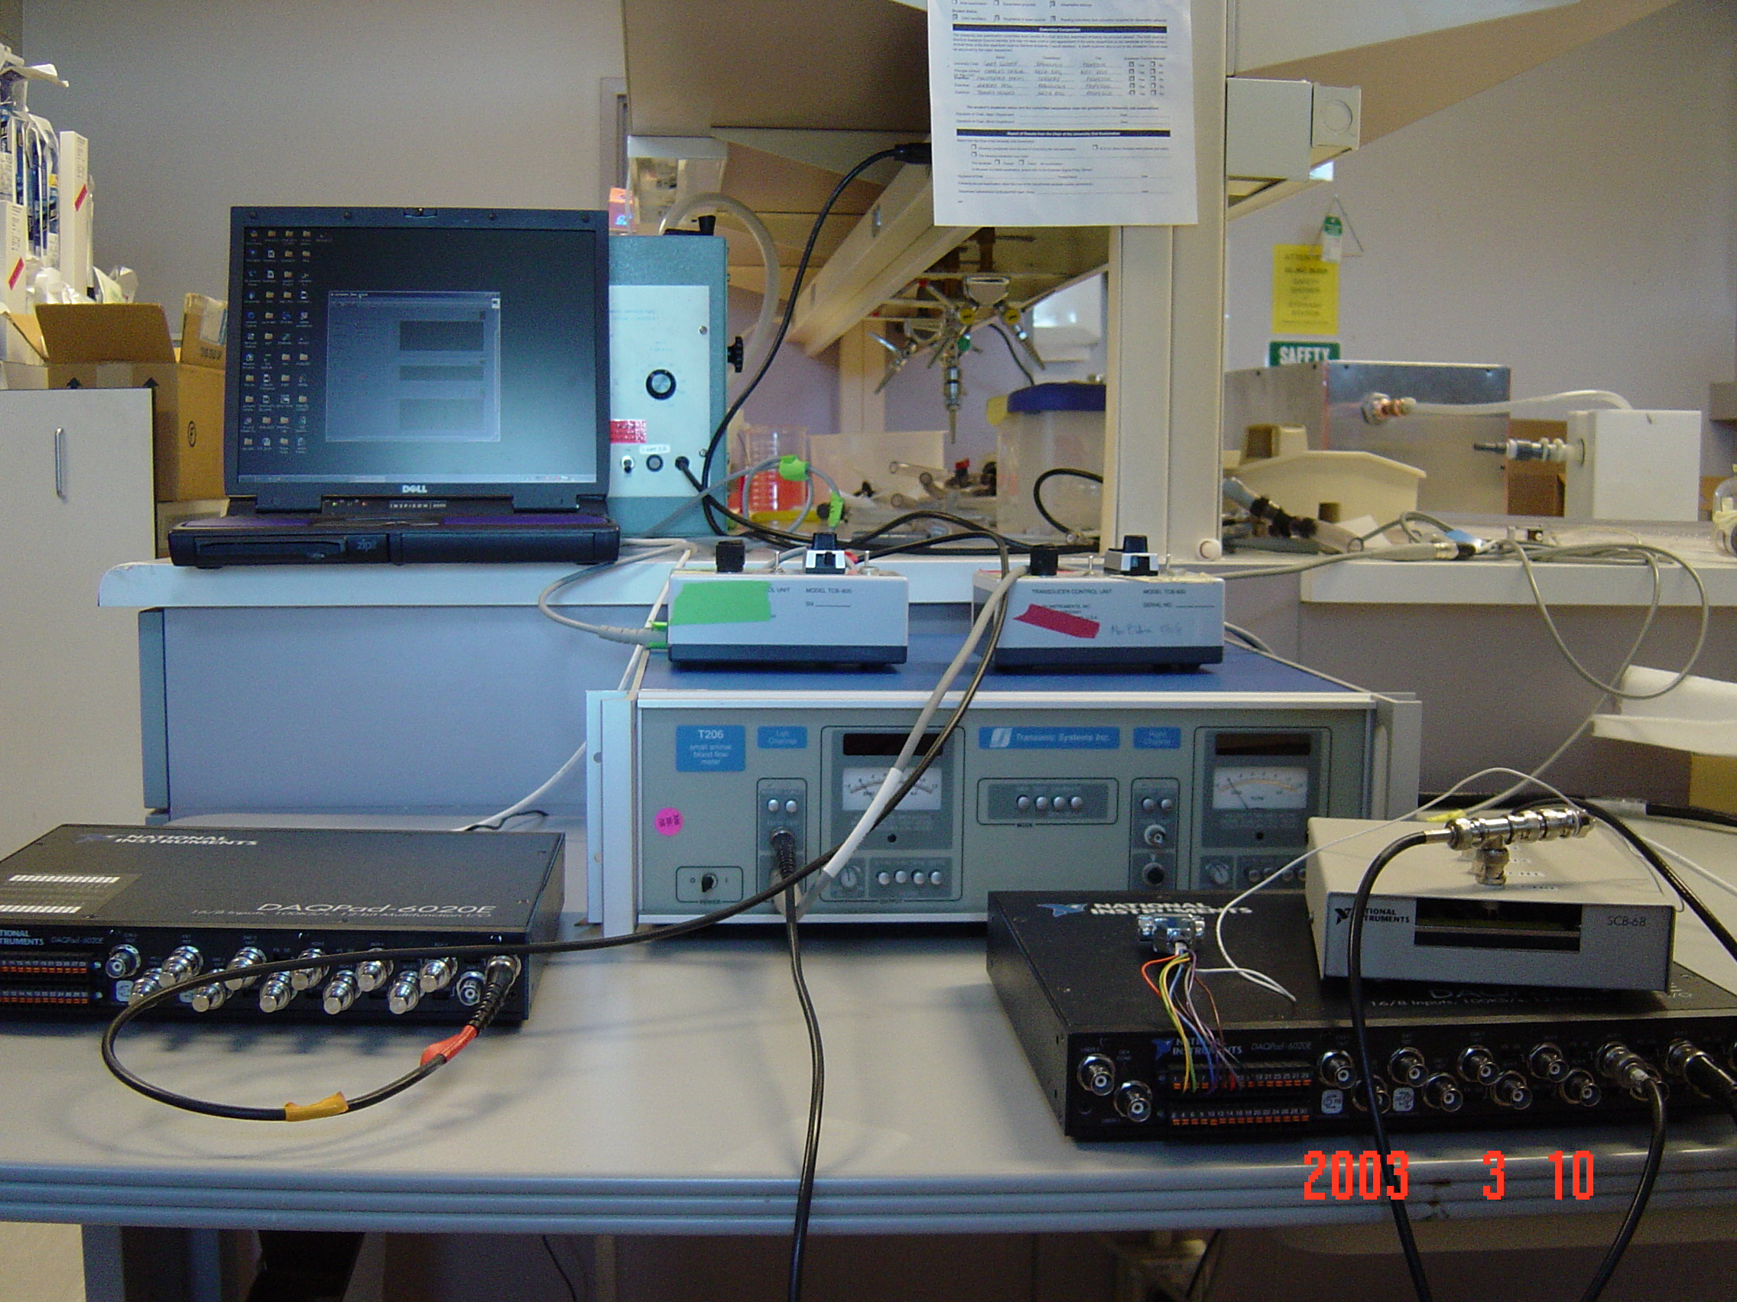
Figure 51: Data Aquistion System

By restricting the flow through the arterial model the team was able to reach a the peak physiologic target value of 120/80 mmHg inside the aortic arch. By placing a jar half filled with air in parallel with the flow model, we were able to add compliance to the flow model to compensate for the rigid tubing used to make pump connections. This added compliance helped to damp out the pressure reflections caused by joints and rigid tubing and produce a smoother waveform. The pressure waveform measured in the aortic model is shown below. The compliant urethane aorta produced a life-like reduction in pressure magnitude with distance from the heart.
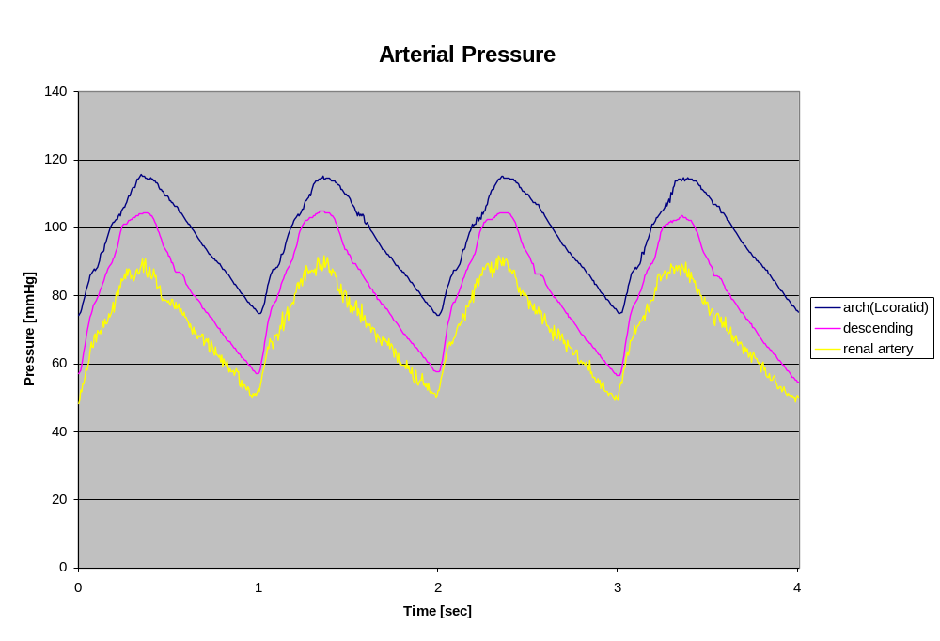
Figure 52: Aortic Pressure Waveform

To measure the flow velocity through the branch arteries, we placed in-line flow meters behind the flow restriction valves follow the converging networks.
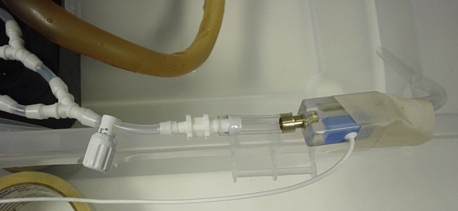
Figure 53: In-line flow meter

By tuning the distal valves, the team was able to maintain physiologic pressure inside the aorta while producing accurate flow velocities in a target region of the model. The target and measured flow velocities as well as the required valve settings are shown in the table below.
Table 2: Flow rate and valve settings
 | Target Region
Flow Rate [mL/min] | Coronary | Renal | Coratid | Diseased Left Coronary
Target value | 500 | 536 | 1550 | n/a
Mean value, Left | 540.8 | 512.1 | 1585.2 | 514.9
Mean value, Right | 506.8 | 510.2 | 1549.6 | 592.9
Valve location | Valve Settings
left coronary | 1.7 | 0 | 0 | 1.55
right coronary | 1.05 | 0 | 0 | 1
left coratid | 0 | 0 | 2.5 | 0
right coratid | 0 | 0 | 2.08 | 0
left renal | 0 | 1.9 | 0 | 0
right renal | 0 | 1.8 | 0 | 0
left iliac | 7.5 | 8.63 | 6.48 | 7.55
right iliac | 0 | 0 | 0 | 0

Our project sponsors were interested to know how the use of coronary arteries with partial occlusions to simulate disease affected the pressure and flow rate. We found that the magnitude and shape of the pressure waveform inside the model did not change significantly with the diseased coronaries. The velocity increased slightly due to the smaller lumen size. These results are important to our sponsors at Guidant who intend to use the model at in their labs but do not have the extensive data acquisition systems available at Stanford to tune the model every time a new coronary artery design is used. Using the recommended valve settings above, the pressure and flow rates inside the model should remain physiologically realistic despite the use of diseased coronary arteries.

Heart Wall Motion
The team is quite pleased with the biphasic contraction and expansion motion exhibited by the heart prototype. Unfortunately, the model has not been observed by a cardiologist to assess the realism of the heart due to time constraints.

Originally the team had planned on validating the motion of the heart wall by both visual inspection by a cardiologist and empirical data taken from two 3D angiogram images as explained in earlier sections. However, both of these validations were heavily reliant on the timely completion of the silicon heart prototype. Due to two separate events beyond our control, mainly software incompatibility and the derailment of the train carrying our casting supplies, the prototype was not finished on time. Thus, we were unable to physically validate our model as planned.

We did, however, create a method of predicting the motion of the coronary arteries. The main goal of the beating heart is to properly displace the coronary arteries to add a sense of clinical realism to the SAM. Thus the most important aspect of the heart wall motion is the displacement of the ventricle walls. We have created a finite element model for the purposes of predicting the motion of the ventricle walls and to aid in the improvement of subsequent prototypes.

The finite element model uses the geometry of the lower half of the heart, imported from the CAD model, as well as the material properties of silicon to predict the displacement of the walls under a given pressure. A CAD surface model of the lower half of the heart was imported into ANSYS 5.7 and meshed with the auto-mesh tool.

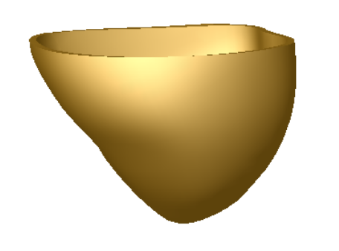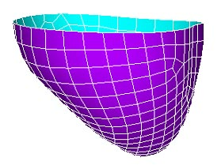
Figure 54: Transformation of Solidworks CAD file to ANSYS meshed finite element model.

Since the lower half is fixed rigidly to the upper half of the heart, a zero displacement boundary condition was added to the upper most edge of the heart. To simulate the 1.16 psi pressure created by the water inside the chamber, a uniformly applied pressure was added. The Dragon Skin silicon used in our model has a tensile modulus of 475psi and a poison’s ration of 0.48. Figure 55 shows the applied boundary conditions.
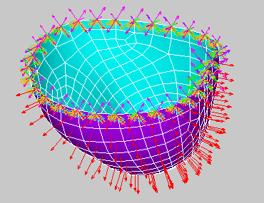
Figure 55: Boundary conditions applied to ANSYS model. Orange triangles represent constraint of all D.O.F. Red arrows represents the uniform internal pressure applied to the normal to the inner surface.

To validate the accuracy of the model, it was first analyzed against an older heart which Guidant had previously created. This heart was made of urethane with an assumed tensile modulus of 425 psi. A series of displacements were measured from the urethane model and compared the output from the FE model. Table 3 shows the results of both analysis.

 | Zone 1 | Zone 2 | Zone 3 | Zone 4 | Zone 5 | Zone 6
Physical Model | 0.0306 | 0.0204 | 0.0102 | 0.0485 | 0.0291 | 0.0058
Default Mesh | 0.0151 | 0.0243 | 0.0181 | 0.0377 | 0.0587 | 0.0098
Smart 2 Mesh | 0.0175 | 0.0266 | 0.0187 | 0.0338 | 0.0519 | 0.0084
Table 3: FEA and validation model results (inches)
Six zones were chosen to represent the motion of the heart wall. The model correlates strongly with zones 2,3,4,and 6. Zones 1 and 5 both had unusually thin or thick walls and should therefore be eliminated form the analysis. Although this validation is not ideal, it gives the FE model a creditability in prediction the motion of the heart.

Next an analysis was done for the model made of silicon. Figure 56 shows the contour plot of the resulting displacements.
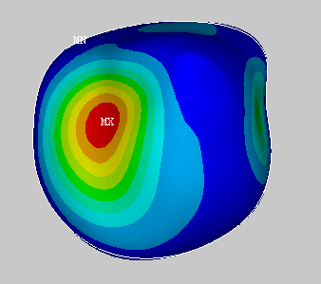
Figure 56: (Top view of model) Displacement contour plot for silicon model. (inches)

It is evident that the displacement of this model does not completely correlate with the data taken from the coronary arteries. The magnitudes of the displacements agree with the data, however, the displacement geometry is less than ideal.

With this information, the model was improved by varying the wall thickness at key points and the model was run again. Considering the location of the coronary arteries shown in Figure 57, discrete areas of the model were targeted during the analysis.

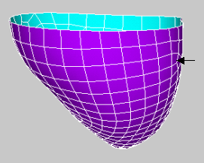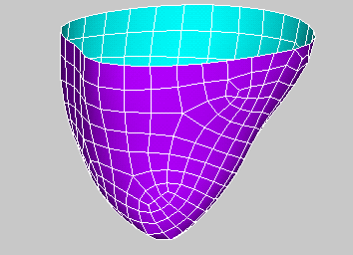
4
2
1
5
3
7
6
Figure 57: Target areas for coronary displacement analysis. Numbers show the approximate location of the target areas.

The resulting displacements were recorded and analyzed against the coronary artery data. This process was iterated until the design was optimized. Unfortunately, not all targeted displacements can be met. The Table 4 shows that five of the seven zones will achieve the desired displacements when the model is run at 3 psi.
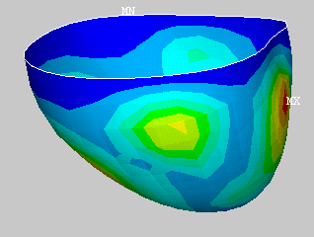
Figure 58: Displacement contour plot of optimized model (inches). Uniform pressure applied, 3psi

 | Area 1 | Area 2 | Area 3 | Area 4 | Area 5 | Area 6 | Area 7
Optimized | 0.1160 | 0.0547 | 0.1350 | 0.1330 | 0.0241 | 0.0473 | 0.0897
Actual | 0.1107 | 0.0681 | 0.1421 | 0.1227 | 0.0658 | 0.0913 | 0.0890
% Error | 4.7504 | 19.6897 | 5.0051 | 8.3877 | 63.3995 | 48.1515 | 0.7164
Table 4: Comparison of optimized FEA model with actual displacement values (inches)

Considering the above results it is our recommendation that, for future prototypes, a non uniform wall thickness is applied to the ventricle walls in accordance with Figure 59 below.

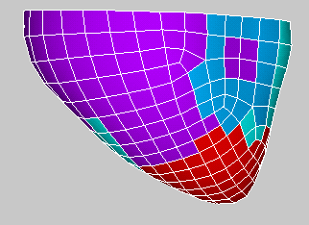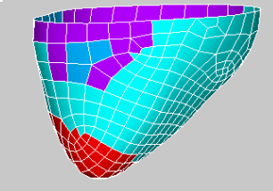
(A) (B)
Color | Thickness (inches)
Red | 0.075
Purple | 0.100
Blue | 0.230
Green | 0.350
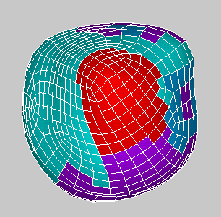
(C)
Figure 59: Optimized model with areas of constant thickness color coded. (A) Front view. (B) Rear view (C) Top view

Feedback Summary
Faculty
We have received useful feedback from our Stanford faculty mentors and project sponsors at Guidant Preclinical R&D. Dr. Charles Taylor suggested the use of the circuit simulation software, CircuitMaker 2000 for the design of cardiovascular flow systems. This program again proved useful in designing the circuit to actuate the heart valves.

Sponsor
When it became clear that it would be difficult to achieve physiologic conditions in all of the branching arteries simultaneously, our sponsors suggested that we develop recommended settings for each target area. Designers and physicians will only deploy a device in one area of the model (primarily the coronary arteries) at one time and therefore we could compromise the accuracy of flow conditions in the other arteries. This simplified the design of our flow model significantly. They also cautioned us that during the design of the flow model we position the flow restriction valves out of the fluoroscopic field of view. Additionally, our sponsors were interested to know how the presence of disease sites in the coronary arteries affected the flow rate through the model. Diseased coronaries are frequently used for device testing and our sponsors will be unable to measure the arterial pressure and velocity in their lab.
Finally our sponsors at Guidant feel that our fluoro-compatible bi-phasic beating heart is sufficiently novel and non-obvious to be patented.

Vendor
We had intended to have our heart model positives manufactured at the Guidant rapid prototyping facility in Temecula, CA but our heart model was very complex and their older stereolithograpy (SLA) equipment could not handle it. We had similar problem trying to load our files onto FDM in the Stanford Product Realization Lab. Outside vendors quoted us a price for the five heart models that exceeded our entire project budget. Scott McMillan, a representative of Javelin 3D suggested we fabricate our heart mold positives by 3D-printing instead of expensive SLA. The printed parts, infused with urethane for strength, made excellent mold positives.

Executive Committee feedback
The executive committees were helpful in monitoring the progress of our project. Feedback from the Reliability and Validation committee at the project definition phase of the project ensured that we had established quantitative criterion by which to evaluate the model. The Technical Resources committee advised us that careful selection of flexible and strong materials for heart walls would be necessary. The Design Review committee cautioned us that synchronizing the flow model with the heart wall motion would not be easy. The Project Management committee suggested that we develop the flow model and beating heart prototype in parallel given the time available.

Design Evaluation
Our team feels that we have met the overall goal of the project; to improve the clinical realism of the SAM for Guidant designers. We developed a simple system of distal valves to regulate pulsatile flow from a Harvard Apparatus pump to produce physiologic pressure and flow rates in target areas of the model. We also designed and manufactured a prototype beating heart that displays dramatic biphasic motion. We were able to use a manufacturing process similar to that currently used by Guidant technicians to manufacture the solid hearts used in the SAM. Therefore, the interface between the heart and the coronary arteries (the critical point of focus in the SAM) remains largely the same. We created a set of flexible molds to cast our prototype that can be used at Guidant to make additional heart prototypes in the future and continue the design process. The wall thickness and inlet diameter of the ventricle chamber could be altered in the next heart iteration to produce more realistic expansion.

The original problem statement we received from Guidant (see Appendix) listed the following desired deliverables:
- Knee to neck anatomy (integrate provided venous and arterial anatomy)
- Pulsatile flow at body temperature
- Femoral, radial, and subclavian access to the heart
- Simulated beating heart (coronaries and heart wall motion)
- Simulated diaphragm movement as it relates to renal artery and kidney respiratory motion (and ability to “hold a breath”)
- Ability to visualize the anatomy under x-ray fluoroscopy – similar tissue radiodensity
- Ability to replace modular vascular anatomy (“plug and play”)

With the exception of the diaphragm motion, the team has developed solutions to incorporate all of the desired features into the synthetic model. The diaphragm motion was designated a lower priority by our project sponsors because of their focus on the treatment of coronary artery disease. Therefore, the team decided early in the winter quarter to focus our attention on the flow model and heart prototyping. The flow regulation system and beating heart mechanism fulfill all of the physical requirements outlined in the project description. The team used fluid-filled cavities to generate heart wall motion and moved the flow restriction valves outside of the field of view of a fluoroscope to ensure that all visible model components are transparent under fluoroscopy. This allows medical devices operating inside model to be visualized. At our sponsor’s request, the heart prototype is slightly larger than the solid SAM heart to create more surface area for the coronary arteries. The prototype heart will still fit inside the chest cavity of the phantom body.

The introduction of a beating heart and physiologic pulsatile flow is extremely useful to device designers. By incorporating these features into the SAM, designers can test the performance of devices under operating conditions in the early stages of product development without the expense of animal studies. This early feedback can save time and money and produce safer, more effective medical devices. Operating on a beating heart is one of the major challenges of minimally invasive cardiac surgery. By providing device engineers and physicians with a clinically realistic training ground, this challenge can be met and new treatments for cardiovascular disease can be made possible.

Future Steps
The pre-clinical flow model that we have developed will primarily be used at the Guidant In Vito Preclinical Research and Development center in Santa Clara, CA. They also intend to fabricate more copies of our flow model and send it to the Guidant Training Centers in Belgium and Japan. They plan to use the model during the early phases of device design to test cardiovascular products under realistic operating conditions. Once a design is fully developed, the model is used again as a marketing tool for physician training.

Recomendations
For the purposes of this project, the motion produced by the heart model adds adequate coronary displacement. However, the displacement values are not completely accurate according to the data taken for the coronary CAD model. It is our recommendation that the team at Guidant create a secondary prototype which incorporates the variable wall thickness calculated in the FEA analysis described above. See Figure XX for the suggested wall thickness values and locations.

VI Project Plan
The biggest change in our plan was the fabrication of the heart prototype. It was delayed more 3 weeks than what we expected. The major problem was the arrival of our molding materials. Due to a shipping accident, we couldn’t get the materials at the expected time. Because of this, we had to spend a lot of time for searching other local distributors.

We did some additional works which was not included in original project plan, such as creating a control circuit, 3D printing of our mold positives and FEA validation. We also spent an extra week for Flow Tuning. The two figures below are the original time table which we expected at the beginning of this quarter and the time table reflecting the our actual progress throughout the spring quarter.

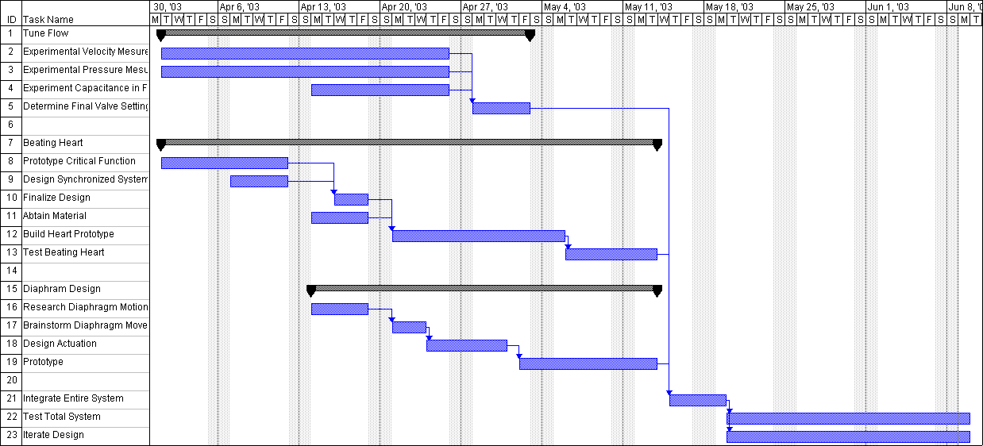
Figure 60: Original project plan

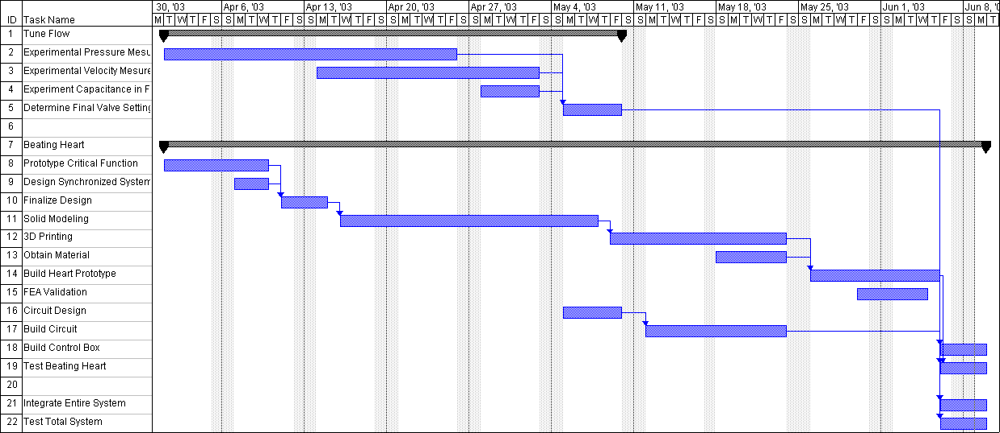
Figure 61: Actual Timeline

VII References
Patents
- Beating heart Model for Training of Coronary Artery Surgery, US Patent 5947744
- The Chamberlain Group: Electrical Beating Heart Model. US Patent (pending) 20020061503
- A Pulsatile flow system for cardiovascular device testing, US Patent 6058958
- Mechanism for controlling Pulsatile Fluid Flow, US Patent 3639084
- Pulsatile flow delivery apparatus, US Patent 4976593
- Infinitely variable Pneumatic Pulsatile Pump, US Patent 5924448

Literature
- “Use of a Pulsatile Beating Heart Model for Training Surgeons in Beating Heart Surgery”; Heart Sugery Forum; Vol2, Issue 4.
- Bowles, Christopher, et.al; “Development of mock circulation models for the assessment of counter pulsation systems”; Cardiovascular Research; 1991; 25:901-908.”
- Westerhof, Nicolaas; Eliznga G., Sipkema P.; “An artificial arterial system for pumping hearts.”; Journal of Applied Physiology; Vol. 31; No5; November 1971.
- Netter, F.; Atlas of the human anatomy 2nd Edition. Novartis: East Hanover, 1997 (Durand 003)
- McDonald, D.A.; Blood Flow in the Arteries 2nd Edition. Edward Arnold, 1974.
- Taylor, C. A.; ME384 (Cardiovascular BioEngineering) lecture notes, Winter 2002.

Internet
- http://www.harvardapparatus.com/pdffiles/newpro_pdf/NP1_030.pdf
- http://www.efunda.com/formulae/solid_mechanics/mat_mechanics/pressure_vessel.cfm
- http://www.guidant.com

VIII Appendices

Presentation Slides
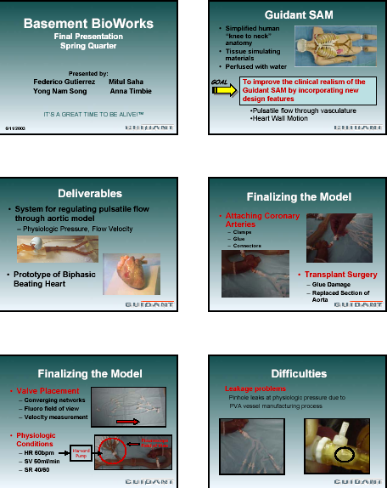

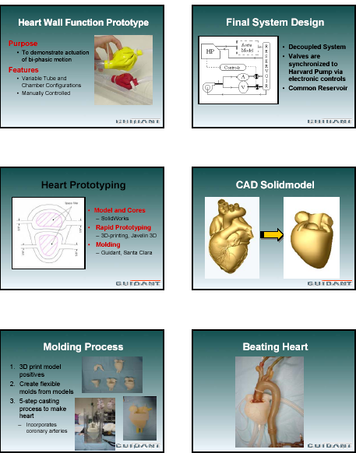

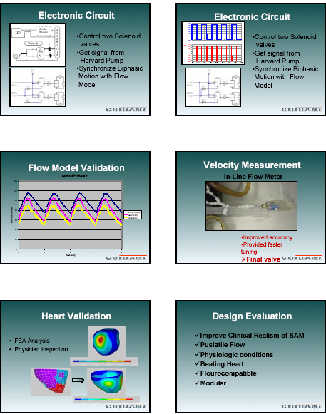

Distributors
Aldrich
6000 North Teutonia Ave
Milwaukee, WI 53209
800-558-9160

Douglas and Sturgess, Inc.
730 Bryant St
San Francisco, CA
415-421-2256

Javelin 3D
470 Lawndale Dr
Salt Lake City, UT 84115
801-466-5649
www.javelin3d.com
Contact: Scott McMillan

McMaster-Carr Supply Company
9630 Norwalk Blvd
Santa Fe Springs, CA 90670-2932
562-692-5911

Tap Plastics
312 Castro St
Mountain View, CA 94041
650-962-8430

Valin Corporation
555 East California Ave
Sunnyvale, CA 94086
408-730-9850



